UNITED STATES
SECURITIES AND EXCHANGE COMMISSION
WASHINGTON, D.C. 20549

Form 8-K

CURRENT REPORT
PURSUANT TO SECTION 13 OR 15(D) OF THE SECURITIES EXCHANGE ACT OF 1934

DATE OF REPORT - July 20, 2026
(Date of earliest event reported)

SOLSTICE ADVANCED MATERIALS INC.
(Exact name of Registrant as specified in its Charter)

Delaware |  | 001-42812 |  | 33-2919563
(State or other jurisdiction  of incorporation) |  | (Commission File Number) |  | (I.R.S. Employer  Identification Number)

115 Tabor Road
Morris Plains, New Jersey |  | 07950
(Address of principal executive offices) |  | (Zip Code)

Registrant’s telephone number, including area code: (973) 370-8188

Check the appropriate box below if the Form 8-K filing is intended to simultaneously satisfy the filing obligation of the registrant under any of the following provisions:

☒ | Written communications pursuant to Rule 425 under the Securities Act (17 CFR 230.425)
☐ | Soliciting material pursuant to Rule 14a-12 under the Exchange Act (17 CFR 240.14a-12)
☐ | Pre-commencement communications pursuant to Rule 14d-2(b) under the Exchange Act (17 CFR 240.14d-2(b))
☐ | Pre-commencement communications pursuant to Rule 13e-4(c) under the Exchange Act (17 CFR 240.13e-4(c))

Securities registered pursuant to Section 12(b) of the Act:

Title of each class |  | Trading Symbol(s) |  | Name of each exchange on which registered
Common Stock, par value $0.01 per share |  | SOLS |  | The Nasdaq Stock Market LLC

Indicate by check mark whether the registrant is an emerging growth company as defined in Rule 405 of the Securities Act of 1933 (§230.405 of this chapter) or Rule 12b-2 of the Securities Exchange Act of 1934 (§240.12b-2 of this chapter).

Emerging Growth Company ☐

If an emerging growth company, indicate by check mark if the registrant has elected not to use the extended transition period for complying with any new or revised financial accounting standards provided pursuant to Section 13(a) of the Exchange Act. ☐

Item 7.01 Regulation FD.

On July 20, 2026, Solstice Advanced Materials Inc., a Delaware corporation (“Solstice”) issued an investor update presentation regarding the proposed acquisition of Element Solutions Inc, a Delaware corporation (“Element Solutions”) by Solstice. A copy of the investor update presentation is attached as Exhibit 99.1 to this Current Report on Form 8-K (the “Report”) and is incorporated herein by reference.

The information furnished pursuant to this Item 7.01, including Exhibit 99.1, shall not be deemed “filed” for the purposes of Section 18 of the Securities Exchange Act of 1934, as amended (the “Exchange Act”), or otherwise subject to the liabilities of that section, and shall not be deemed to be incorporated by reference into any filing made by Solstice under the Securities Act of 1933, as amended, or the Exchange Act, except as shall be expressly set forth by a specific reference in such filing.

Cautionary Statement Regarding Forward-Looking Statements

This communication contains certain forward-looking statements within the meaning of the federal securities laws made pursuant to the safe harbor provisions of the Private Securities Litigation Reform Act of 1995 with respect to the proposed transaction between Solstice and Element Solutions, that involve substantial risks and uncertainties. These statements can be identified by the fact that they do not relate strictly to historical or current facts, but rather are based on current expectations, estimates, assumptions and projections regarding, among other things, the anticipated benefits and timing of the proposed transaction, synergies, expected future financial position, total addressable market, position in specialty chemicals and advanced materials verticals and the industry, business and financial results of each company and the combined company, including the combined company’s expected Adjusted EBITDA and Adjusted EBITDA margin, expected synergies, net debt and net leverage, anticipated de-leveraging, expected accretion to Adjusted EPS and expected growth, margins and free cash flow. Forward-looking statements often include words such as “anticipates,” “estimates,” “expects,” “positioned,” “projects,” “forecasts,” “intends,” “plans,” “continues,” “could,” “believes,” “may,” “will,” “would,” “should,” “goals,” “pro forma” and words and terms of similar substance in connection with discussions of the proposed transaction and the future operating or financial performance of the combined company. As with any projection or forecast, forward-looking statements are inherently susceptible to uncertainty and changes in circumstances. Solstice’s, Element Solutions’ or the combined company’s actual results may vary materially from those expressed or implied in the forward-looking statements. Accordingly, undue reliance should not be placed on any forward-looking statement made by Solstice or on its behalf. Although Solstice and Element Solutions believe that the forward-looking statements contained in this communication are based on reasonable assumptions, you should be aware that a variety of factors, many of which are difficult to predict and outside of Solstice’s or Element Solutions’ control, could affect Solstice’s, Element Solutions’ or the combined company’s actual financial results or results of operations and could cause actual results to differ materially from those in such forward-looking statements, including, but not limited to: the completion of the proposed transaction on the anticipated terms and timing, including obtaining stockholder, regulatory and other approvals, anticipated tax treatment, unforeseen liabilities, future capital expenditures, revenues, expenses, earnings, synergies, economic performance, indebtedness, financial condition, future prospects, business and management strategies, expansion and growth of Solstice’s and Element Solutions’ businesses and other conditions to the completion of the proposed transaction; failure to realize the anticipated benefits of the proposed transaction, or that such benefits may take longer to realize or be more costly to achieve than expected, including as a result of delay in completing the proposed transaction, Solstice’s ability to integrate Element Solutions’ operations and product lines or due to unexpected costs, liabilities or delays; the ability of the parties to obtain or consummate financing related to the proposed transaction upon acceptable terms or at all; the dilution caused by Solstice’s issuance of additional shares of its common stock in connection with the consummation of the proposed transaction; the risk of a downgrade of the credit rating of Solstice’s indebtedness; a material adverse change in the financial condition of Solstice, Element Solutions or the combined company; potential litigation relating to the proposed transaction that could be instituted against Solstice, Element Solutions or their respective directors; Solstice’s and Element Solutions’ ability to implement their business strategies; the risk that disruptions from the proposed transaction will harm Solstice’s or Element Solutions’ respective businesses, including current plans and operations; the ability of Solstice or Element Solutions to retain and hire key personnel; potential adverse reactions or changes to business relationships resulting from the announcement or completion of the proposed transaction; uncertainty as to the long-term value of Solstice’s common stock; risks associated with third party contracts containing consent and/or other provisions triggered by the proposed transaction; legislative, regulatory, political and economic developments affecting Solstice’s, Element Solutions’ or the combined company’s respective businesses; the evolving legal, regulatory and tax regimes under which Solstice and Element Solutions operate; potential business uncertainty, including changes to existing business relationships, during the pendency of the proposed transaction that could affect Solstice’s and/or Element Solutions’ financial performance; restrictions during the pendency of the proposed transaction that may impact Solstice’s or Element Solutions’ ability to pursue certain business opportunities or strategic transactions; an overall decline in the health of the economy and the industries in which Solstice and Element Solutions operate, including as a result of inflation, tariffs and other trade barriers and restrictions, market volatility, geopolitical instability and social unrest, the possibility of an economic downturn or recession or other macroeconomic factors; unpredictability and severity of catastrophic events, including, but not limited to, acts of terrorism or outbreak of war or hostilities, as well as Solstice’s and Element Solutions’ response to any of the aforementioned factors; failure to receive the approval of the stockholders of Solstice and/or Element Solutions; and the occurrence of any event, change or other circumstance that could give rise to the termination of the merger agreement. The foregoing list of factors is not exhaustive. You should carefully consider the foregoing factors and the other risks and uncertainties that affect the businesses of Solstice and Element Solutions described in the “Risk Factors” section of their respective Annual Reports on Form 10-K for the year ended December 31, 2025, Quarterly Reports on Form 10-Q and other documents filed by either of them from time to time with the SEC. These filings identify and address other important risks and uncertainties that could cause actual events and results to differ materially from those implied by forward-looking statements in this communication. Forward-looking statements speak only as of the date they are made. Readers are cautioned not to put undue reliance on forward-looking statements, and Solstice and Element Solutions assume no obligation and do not intend to update or revise these forward-looking statements, whether as a result of new information, future events or otherwise, except as otherwise required by securities or other applicable law. Neither Solstice nor Element Solutions gives any assurance that either Solstice or Element Solutions will achieve its expectations.

1

Important Information and Where to Find It

In connection with the proposed transaction, Solstice intends to file with the SEC a registration statement on Form S-4 (the “Registration Statement”), which will include a prospectus with respect to the shares of Solstice’s common stock to be issued in the proposed transaction and a joint proxy statement for Solstice’s and Element Solutions’ respective stockholders (the “Joint Proxy Statement/Prospectus”). The definitive Joint Proxy Statement/Prospectus (if and when available) will be mailed to stockholders of Solstice and Element Solutions after it is declared effective. Each of Solstice and Element Solutions may also file with or furnish to the SEC other relevant documents regarding the proposed transaction. This communication is not a substitute for the Registration Statement, the Joint Proxy Statement/Prospectus or any other document that Solstice or Element Solutions may mail to their respective stockholders in connection with the proposed transaction.

INVESTORS AND SECURITY HOLDERS OF SOLSTICE AND ELEMENT SOLUTIONS ARE URGED TO READ THE REGISTRATION STATEMENT AND THE JOINT PROXY STATEMENT/PROSPECTUS INCLUDED WITHIN THE REGISTRATION STATEMENT CAREFULLY AND IN THEIR ENTIRETY WHEN THEY BECOME AVAILABLE, AS WELL AS ANY OTHER RELEVANT DOCUMENTS FILED WITH THE SEC IN CONNECTION WITH THE PROPOSED TRANSACTION OR INCORPORATED BY REFERENCE INTO THE REGISTRATION STATEMENT AND THE JOINT PROXY STATEMENT/PROSPECTUS (INCLUDING ANY AMENDMENTS OR SUPPLEMENTS THERETO), BECAUSE THEY WILL CONTAIN IMPORTANT INFORMATION REGARDING SOLSTICE, ELEMENT SOLUTIONS, THE PROPOSED TRANSACTION AND RELATED MATTERS.

Investors and security holders may obtain free copies of the Joint Proxy Statement/Prospectus and other documents filed with the SEC by Solstice or Element Solutions through the website maintained by the SEC at http://www.sec.gov or from Solstice at its website, https://www.solstice.com, or from Element Solutions at its website, https://www.elementsolutionsinc.com (information included on or accessible through the SEC website or either of Solstice’s or Element Solutions’ website is not incorporated by reference into this communication).

Participants in Solicitation

Solstice and Element Solutions and their respective directors and executive officers may be deemed to be participants in the solicitation of proxies from the stockholders of Solstice and Element Solutions in connection with the proposed transaction.

Information about the interests of the directors and executive officers of Solstice and Element Solutions and other persons who may be deemed to be participants in the solicitation of stockholders of Solstice and Element Solutions in connection with the proposed transaction and a description of their direct and indirect interests, by security holdings or otherwise, will be included in the Joint Proxy Statement/Prospectus, which will be filed with the SEC.

Information about Solstice’s directors and executive officers and their ownership of Solstice’s common stock is set forth in Solstice’s proxy statement for its 2026 Annual Meeting of Stockholders on Schedule 14A filed with the SEC on April 2, 2026 under the headings “Director Compensation,” “Compensation Discussion and Analysis,” “Executive Compensation Tables” and “Stock Ownership Information.” To the extent that holdings of Solstice’s securities have changed since the amounts printed in Solstice’s proxy statement, such changes have been or will be reflected on Initial Statements of Beneficial Ownership of Securities on Form 3 and Statements of Changes in Beneficial Ownership on Form 4 filed with the SEC.

Information about Element Solutions’ directors and executive officers and their ownership of Element Solutions’ common stock is set forth in Element Solutions’ proxy statement for its 2026 Annual Meeting of Stockholders on Schedule 14A filed with the SEC on March 23, 2026, under the headings “Director Compensation,” “Executive Compensation” and “Security Ownership.” To the extent that holdings of Element Solutions’ securities have changed since the amounts printed in Element Solutions’ proxy statement, such changes have been or will be reflected on Initial Statements of Beneficial Ownership of Securities on Form 3 and Statements of Changes in Beneficial Ownership on Form 4 filed with the SEC.

The information regarding the direct and indirect interests of those persons and other persons who may be deemed participants in the proposed transaction may be obtained by reading the Joint Proxy Statement/Prospectus regarding the proposed transaction when it becomes available. Free copies of these documents may be obtained as described above.

2

No Offer or Solicitation

This communication is not intended to and shall not constitute an offer to sell or the solicitation of an offer to sell or the solicitation of an offer to buy any securities, or a solicitation of any vote or approval, nor shall there be any sale of securities in any jurisdiction in which such offer, solicitation or sale would be unlawful prior to registration or qualification under the securities laws of any such jurisdiction. No offer of securities shall be made except by means of a prospectus meeting the requirements of Section 10 of the Securities Act of 1933, as amended (the “Securities Act”), and/or offered pursuant to an exemption from the registration requirements of the Securities Act, and otherwise in accordance with applicable law.

Important Note about Combined and Non-GAAP Financial Information

The financial information for the combined businesses of Solstice and Element Solutions is based on management's estimates, assumptions and projections and has not been prepared in conformance with the applicable requirements of Regulation S-X relating to pro forma financial information, and the required pro forma adjustments have not been applied and are not reflected therein. This information is provided for illustrative purposes only and should not be considered in isolation from, or as a substitute for, the historical financial statements of Solstice and Element Solutions. These measures are provided for illustrative purposes and are based on an arithmetic sum of the relevant historical financial measures of Solstice and Element Solutions. Combined Adjusted EBITDA is the arithmetic sum of Solstice’s Adjusted Standalone EBITDA and Element Solutions’ Pro Forma Adjusted EBITDA, inclusive of expected synergies. Combined Adjusted EBITDA Margin is inclusive of expected synergies. These measures do not reflect what the combined company's financial condition or results of operations would have been had the proposed transaction occurred on or prior to the dates indicated. Such illustrative information may differ materially from pro forma information included in SEC filings. Various factors could cause actual future results to differ materially from those currently estimated by management, including, but not limited to, the risks described above and in each of Solstice’s and Element Solutions’ respective filings with the SEC.

This communication also includes certain financial measures not calculated in accordance with U.S. generally accepted accounting principles ("GAAP"), such as adjusted standalone EBITDA, pro forma adjusted EBITDA, combined adjusted EBITDA, combined adjusted EBITDA margin, combined sales, synergies, integration benefits, free cash flow, net debt and net leverage. Non-GAAP financial measures have limitations as an analytical tool and are not meant to be considered in isolation from, or as a substitute for, the comparable GAAP measures. There are limitations to non-GAAP financial measures because they are not prepared in accordance with GAAP and may not be comparable to similarly titled measures of other companies due to potential differences in methods of calculation and items being excluded. Solstice and Element Solutions caution you not to place undue reliance on these non-GAAP financial measures.

For a definition of Solstice’s adjusted standalone EBITDA and Element Solutions’ adjusted EBITDA and a reconciliation of adjusted standalone EBITDA and adjusted EBITDA to the most comparable GAAP financial measure for 2025, please see Solstice’s Current Report on Form 8-K furnished with the SEC on February 11, 2026 and Element Solutions’ Current Report on Form 8-K furnished with the SEC on February 17, 2026 and Element Solutions’ 2026 Investor Day presentation at its website at https://www.elementsolutions.com (information included on or accessible through Element Solutions’ website is not incorporated by reference into this communication). Element Solutions’ pro forma Adjusted EBITDA for fiscal year 2025 is from Element Solutions’ 2026 Investor Day presentation and is Element Solutions’ Adjusted EBITDA inclusive of a pro forma adjustment of $61 million from the impact of the acquisitions of Micromax and EFC Gases. Combined Adjusted EBITDA and Combined Adjusted EBITDA margin includes expected synergies.

Item 9.01 Financial Statements and Exhibits

(d) Exhibits

The following exhibits are filed as part of this Report:

Exhibit No. |  | Exhibit
99.1 |  | Investor Update Presentation.
104 |  | Cover Page Interactive Data File (the cover page XBRL tags are embedded within the Inline XBRL document).

3

SIGNATURES

Pursuant to the requirements of the Securities Exchange Act of 1934, the registrant has duly caused this report to be signed on its behalf by the undersigned hereunto duly authorized.

Date: July 20, 2026 | SOLSTICE ADVANCED MATERIALS INC.
 | By: | /s/ Brian Rudick
 |  | Brian Rudick
 |  | Senior Vice President, General Counsel & Secretary

4

Exhibit 99.1


Investor Update July 20th, 2026 Solstice Advanced Materials to Acquire Element Solutions Capturing a Generational Growth Opportunity DRAFT as of 14 - July

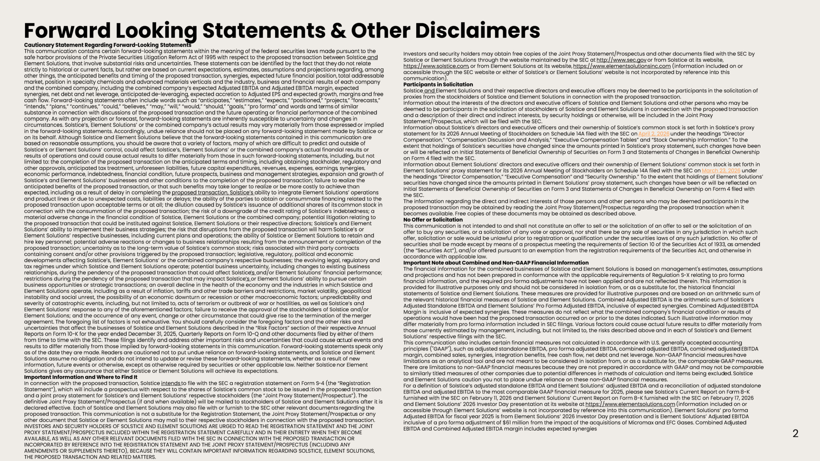
Cautionary Statement Regarding Forward - Looking Statements This communication contains certain forward - looking statements within the meaning of the federal securities laws made pursuant t o the safe harbor provisions of the Private Securities Litigation Reform Act of 1995 with respect to the proposed transaction betwe en Solstice and Element Solutions, that involve substantial risks and uncertainties. These statements can be identified by the fact that they do not relate strictly to historical or current facts, but rather are based on current expectations, estimates, assumptions and projections re garding, among other things, the anticipated benefits and timing of the proposed transaction, synergies, expected future financial position, total addressable market, position in specialty chemicals and advanced materials verticals and the industry, business and financial results of eac h company and the combined company, including the combined company's expected Adjusted EBITDA and Adjusted EBITDA margin, expected synergies, net debt and net leverage, anticipated de - leveraging, expected accretion to Adjusted EPS and expected growth, margins and free cash flow. Forward - looking statements often include words such as "anticipates," "estimates," "expects," "positioned," "projects ," "forecasts," "intends," "plans," "continues," "could," "believes," "may," "will," "would," "should," "goals," "pro forma" and words and te rms of similar substance in connection with discussions of the proposed transaction and the future operating or financial performance of the co mbined company. As with any projection or forecast, forward - looking statements are inherently susceptible to uncertainty and changes in circumstances. Solstice's, Element Solutions' or the combined company's actual results may vary materially from those express ed or implied in the forward - looking statements. Accordingly, undue reliance should not be placed on any forward - looking statement made by Sol stice or on its behalf. Although Solstice and Element Solutions believe that the forward - looking statements contained in this communicati on are based on reasonable assumptions, you should be aware that a variety of factors, many of which are difficult to predict and ou tsi de of Solstice's or Element Solutions' control, could affect Solstice's, Element Solutions' or the combined company's actual financ ial results or results of operations and could cause actual results to differ materially from those in such forward - looking statements, includi ng, but not limited to: the completion of the proposed transaction on the anticipated terms and timing, including obtaining stockholder, reg ulatory and other approvals, anticipated tax treatment, unforeseen liabilities, future capital expenditures, revenues, expenses, earnings , synergies, economic performance, indebtedness, financial condition, future prospects, business and management strategies, expansion and gro wth of Solstice's and Element Solutions' businesses and other conditions to the completion of the proposed transaction; failure to r eal ize the anticipated benefits of the proposed transaction, or that such benefits may take longer to realize or be more costly to achie ve than expected, including as a result of delay in completing the proposed transaction, Solstice's ability to integrate Element Solutions' operations and product lines or due to unexpected costs, liabilities or delays; the ability of the parties to obtain or consummate finan cin g related to the proposed transaction upon acceptable terms or at all; the dilution caused by Solstice's issuance of additional shares of its com mon stock in connection with the consummation of the proposed transaction; the risk of a downgrade of the credit rating of Solstice's inde bte dness; a material adverse change in the financial condition of Solstice, Element Solutions or the combined company; potential litigati on relating to the proposed transaction that could be instituted against Solstice, Element Solutions or their respective directors; Solstice 's and Element Solutions' ability to implement their business strategies; the risk that disruptions from the proposed transaction will harm Sol stice's or Element Solutions' respective businesses, including current plans and operations; the ability of Solstice or Element Solution s t o retain and hire key personnel; potential adverse reactions or changes to business relationships resulting from the announcement or compl eti on of the proposed transaction; uncertainty as to the long - term value of Solstice's common stock; risks associated with third party contra cts containing consent and/or other provisions triggered by the proposed transaction; legislative, regulatory, political and econ omi c developments affecting Solstice's, Element Solutions' or the combined company's respective businesses; the evolving legal, re gul atory and tax regimes under which Solstice and Element Solutions operate; potential business uncertainty, including changes to existing bu siness relationships, during the pendency of the proposed transaction that could affect Solstice 's and/or Element Solutions' financial performance; restrictions during the pendency of the proposed transaction that may impact Solstice 's or Element Solutions' ability to pursue certain business opportunities or strategic transactions; an overall decline in the health of the economy and the industries in which So lstice and Element Solutions operate, including as a result of inflation, tariffs and other trade barriers and restrictions, market vola tility, geopolitical instability and social unrest, the possibility of an economic downturn or recession or other macroeconomic factors; unpredict abi lity and severity of catastrophic events, including, but not limited to, acts of terrorism or outbreak of war or hostilities, as well as Solstice's and Element Solutions' response to any of the aforementioned factors; failure to receive the approval of the stockholders of Sols tic e and/or Element Solutions; and the occurrence of any event, change or other circumstance that could give rise to the termination of t he merger agreement. The foregoing list of factors is not exhaustive. You should carefully consider the foregoing factors and the other risks and uncertainties that affect the businesses of Solstice and Element Solutions described in the "Risk Factors" section of their r esp ective Annual Reports on Form 10 - K for the year ended December 31, 2025, Quarterly Reports on Form 10 - Q and other documents filed by either of them from time to time with the SEC. These filings identify and address other important risks and uncertainties that could cause a ctu al events and results to differ materially from those implied by forward - looking statements in this communication. Forward - looking statements speak only as of the date they are made. Readers are cautioned not to put undue reliance on forward - looking statements, and Solstice and El ement Solutions assume no obligation and do not intend to update or revise these forward - looking statements, whether as a result of ne w information, future events or otherwise, except as otherwise required by securities or other applicable law. Neither Solstice no r Element Solutions gives any assurance that either Solstice or Element Solutions will achieve its expectations. Important Information and Where to Find It In connection with the proposed transaction, Solstice intends to file with the SEC a registration statement on Form S - 4 (the "Registration Statement"), which will include a prospectus with respect to the shares of Solstice's common stock to be issued in the propos ed transaction and a joint proxy statement for Solstice's and Element Solutions' respective stockholders (the "Joint Proxy Statement/Prospec tus "). The definitive Joint Proxy Statement/Prospectus (if and when available) will be mailed to stockholders of Solstice and Element So lutions after it is declared effective. Each of Solstice and Element Solutions may also file with or furnish to the SEC other relevant documents reg arding the proposed transaction. This communication is not a substitute for the Registration Statement, the Joint Proxy Statement/Prospe ctu s or any other document that Solstice or Element Solutions may mail to their respective stockholders in connection with the proposed t ran saction. INVESTORS AND SECURITY HOLDERS OF SOLSTICE AND ELEMENT SOLUTIONS ARE URGED TO READ THE REGISTRATION STATEMENT AND THE JOINT PROXY STATEMENT/PROSPECTUS INCLUDED WITHIN THE REGISTRATION STATEMENT CAREFULLY AND IN THEIR ENTIRETY WHEN THEY BECOME AVAILABLE, AS WELL AS ANY OTHER RELEVANT DOCUMENTS FILED WITH THE SEC IN CONNECTION WITH THE PROPOSED TRANSACTION OR INCORPORATED BY REFERENCE INTO THE REGISTRATION STATEMENT AND THE JOINT PROXY STATEMENT/PROSPECTUS (INCLUDING ANY AMENDMENTS OR SUPPLEMENTS THERETO), BECAUSE THEY WILL CONTAIN IMPORTANT INFORMATION REGARDING SOLSTICE, ELEMENT SOLUTIONS, THE PROPOSED TRANSACTION AND RELATED MATTERS. Forward Looking Statements & Other Disclaimers 2 Investors and security holders may obtain free copies of the Joint Proxy Statement/Prospectus and other documents filed with the SEC by Solstice or Element Solutions through the website maintained by the SEC at http://www.sec.gov or from Solstice at its website, https://www.solstice.com , or from Element Solutions at its website, https://www.elementsolutionsinc.com (information included on or accessible through the SEC website or either of Solstice's or Element Solutions' website is not incorporated by reference int o t his communication). Participants in Solicitation Solstice and Element Solutions and their respective directors and executive officers may be deemed to be participants in the solicitation of proxies from the stockholders of Solstice and Element Solutions in connection with the proposed transaction. Information about the interests of the directors and executive officers of Solstice and Element Solutions and other persons w ho may be deemed to be participants in the solicitation of stockholders of Solstice and Element Solutions in connection with the propos ed transaction and a description of their direct and indirect interests, by security holdings or otherwise, will be included in the Joint Pr oxy Statement/Prospectus, which will be filed with the SEC. Information about Solstice's directors and executive officers and their ownership of Solstice's common stock is set forth in Sol stice's proxy statement for its 2026 Annual Meeting of Stockholders on Schedule 14A filed with the SEC on April 2, 2026 under the headings "Director Compensation," "Compensation Discussion and Analysis," "Executive Compensation Tables" and "Stock Ownership Information." To the extent that holdings of Solstice's securities have changed since the amounts printed in Solstice's proxy statement, such chan ges have been or will be reflected on Initial Statements of Beneficial Ownership of Securities on Form 3 and Statements of Changes in Benef ici al Ownership on Form 4 filed with the SEC. Information about Element Solutions' directors and executive officers and their ownership of Element Solutions' common stock is set forth in Element Solutions' proxy statement for its 2026 Annual Meeting of Stockholders on Schedule 14A filed with the SEC on March 23, 2026 under the headings "Director Compensation," "Executive Compensation" and "Security Ownership." To the extent that holdings of Eleme nt Solutions' securities have changed since the amounts printed in Element Solutions' proxy statement, such changes have been or will be re fle cted on Initial Statements of Beneficial Ownership of Securities on Form 3 and Statements of Changes in Beneficial Ownership on Form 4 f iled with the SEC. The information regarding the direct and indirect interests of those persons and other persons who may be deemed participants in the proposed transaction may be obtained by reading the Joint Proxy Statement/Prospectus regarding the proposed transaction when it becomes available. Free copies of these documents may be obtained as described above. No Offer or Solicitation This communication is not intended to and shall not constitute an offer to sell or the solicitation of an offer to sell or th e s olicitation of an offer to buy any securities, or a solicitation of any vote or approval, nor shall there be any sale of securities in any juri sdi ction in which such offer, solicitation or sale would be unlawful prior to registration or qualification under the securities laws of any such ju ris diction. No offer of securities shall be made except by means of a prospectus meeting the requirements of Section 10 of the Securities Act of 1933 , a s amended (the "Securities Act"), and/or offered pursuant to an exemption from the registration requirements of the Securities Act, and otherwise in accordance with applicable law. Important Note about Combined and Non - GAAP Financial Information The financial information for the combined businesses of Solstice and Element Solutions is based on management's estimates, a ssu mptions and projections and has not been prepared in conformance with the applicable requirements of Regulation S - X relating to pro form a financial information, and the required pro forma adjustments have not been applied and are not reflected therein. This infor mat ion is provided for illustrative purposes only and should not be considered in isolation from, or as a substitute for, the historica l financial statements of Solstice and Element Solutions. These measures are provided for illustrative purposes and are based on an arith met ic sum of the relevant historical financial measures of Solstice and Element Solutions. Combined Adjusted EBITDA is the arithmetic sum of Solstice's Adjusted Standalone EBITDA and Element Solutions' Pro Forma Adjusted EBITDA, inclusive of expected synergies. Combined Adjust ed EBITDA Margin is inclusive of expected synergies. These measures do not reflect what the combined company's financial condition or res ults of operations would have been had the proposed transaction occurred on or prior to the dates indicated. Such illustrative inform ati on may differ materially from pro forma information included in SEC filings. Various factors could cause actual future results to di ffe r materially from those currently estimated by management, including, but not limited to, the risks described above and in each of Solstice's a nd Element Solutions' respective filings with the SEC. This communication also includes certain financial measures not calculated in accordance with U.S. generally accepted account ing principles ("GAAP"), such as adjusted standalone EBITDA, pro forma adjusted EBITDA, combined adjusted EBITDA, combined adjust ed EBITDA margin, combined sales, synergies, integration benefits, free cash flow, net debt and net leverage. Non - GAAP financial measures have limitations as an analytical tool and are not meant to be considered in isolation from, or as a substitute for, the comparabl e G AAP measures. There are limitations to non - GAAP financial measures because they are not prepared in accordance with GAAP and may not be compar able to similarly titled measures of other companies due to potential differences in methods of calculation and items being exclud ed. Solstice and Element Solutions caution you not to place undue reliance on these non - GAAP financial measures. For a definition of Solstice's adjusted standalone EBITDA and Element Solutions' adjusted EBITDA and a reconciliation of adju ste d standalone EBITDA and adjusted EBITDA to the most comparable GAAP financial measure for 2025, please see Solstice's Current Report on Fo rm 8- K furnished with the SEC on February 11, 2026 and Element Solutions' Current Report on Form 8- K furnished with the SEC on February 17, 2026 and Element Solutions' 2026 Investor Day presentation at its website at https://www.elementsolutions.com (information included on or accessible through Element Solutions' website is not incorporated by reference into this communication). Element Solutions' p ro forma Adjusted EBITDA for fiscal year 2025 is from Element Solutions' 2026 Investor Day presentation and is Element Solutions' Adju ste d EBITDA inclusive of a pro forma adjustment of $61 million from the impact of the acquisitions of Micromax and EFC Gases. Combined Ad jus ted EBITDA and Combined Adjusted EBITDA margin includes expected synergies

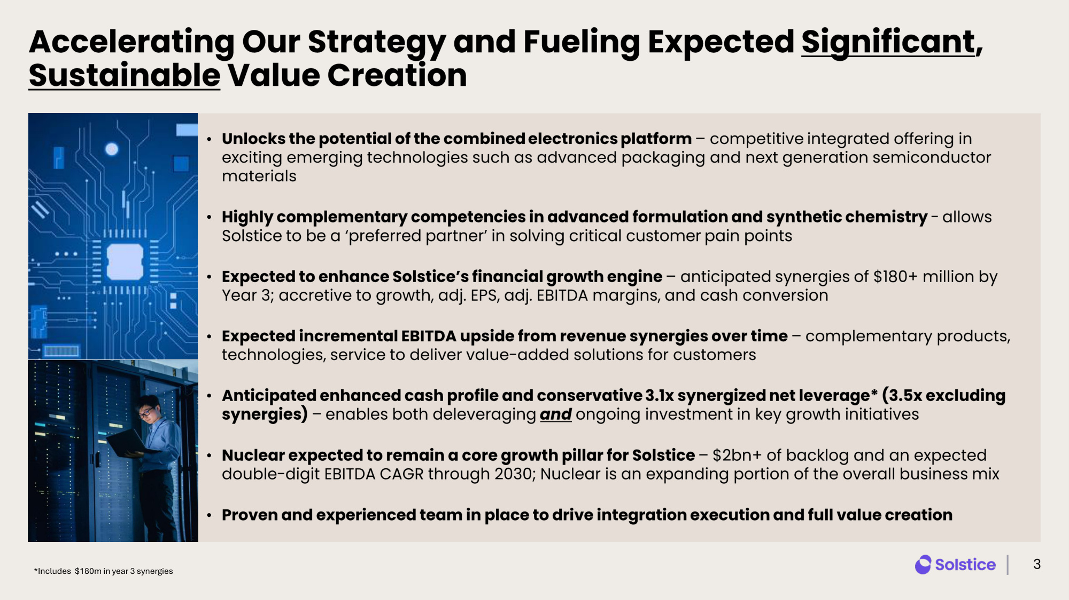
Accelerating Our Strategy and Fueling Expected Significant , Sustainable Value Creation • Unlocks the potential of the combined electronics platform – competitive integrated offering in exciting emerging technologies such as advanced packaging and next generation semiconductor materials • Highly complementary competencies in advanced formulation and synthetic chemistry - allows Solstice to be a 'preferred partner' in solving critical customer pain points • Expected to enhance Solstice's financial growth engine – anticipated synergies of $180+ million by Year 3; accretive to growth, adj. EPS, adj. EBITDA margins, and cash conversion • Expected incremental EBITDA upside from revenue synergies over time – complementary products, technologies, service to deliver value - added solutions for customers • Anticipated enhanced cash profile and conservative 3.1x synergized net leverage * ( 3.5x excluding synergies ) – enables both deleveraging and ongoing investment in key growth initiatives • Nuclear expected to remain a core growth pillar for Solstice – $2bn+ of backlog and an expected double - digit EBITDA CAGR through 2030; Nuclear is an expanding portion of the overall business mix • Proven and experienced team in place to drive integration execution and full value creation 3 *Includes $180m in year 3 synergies

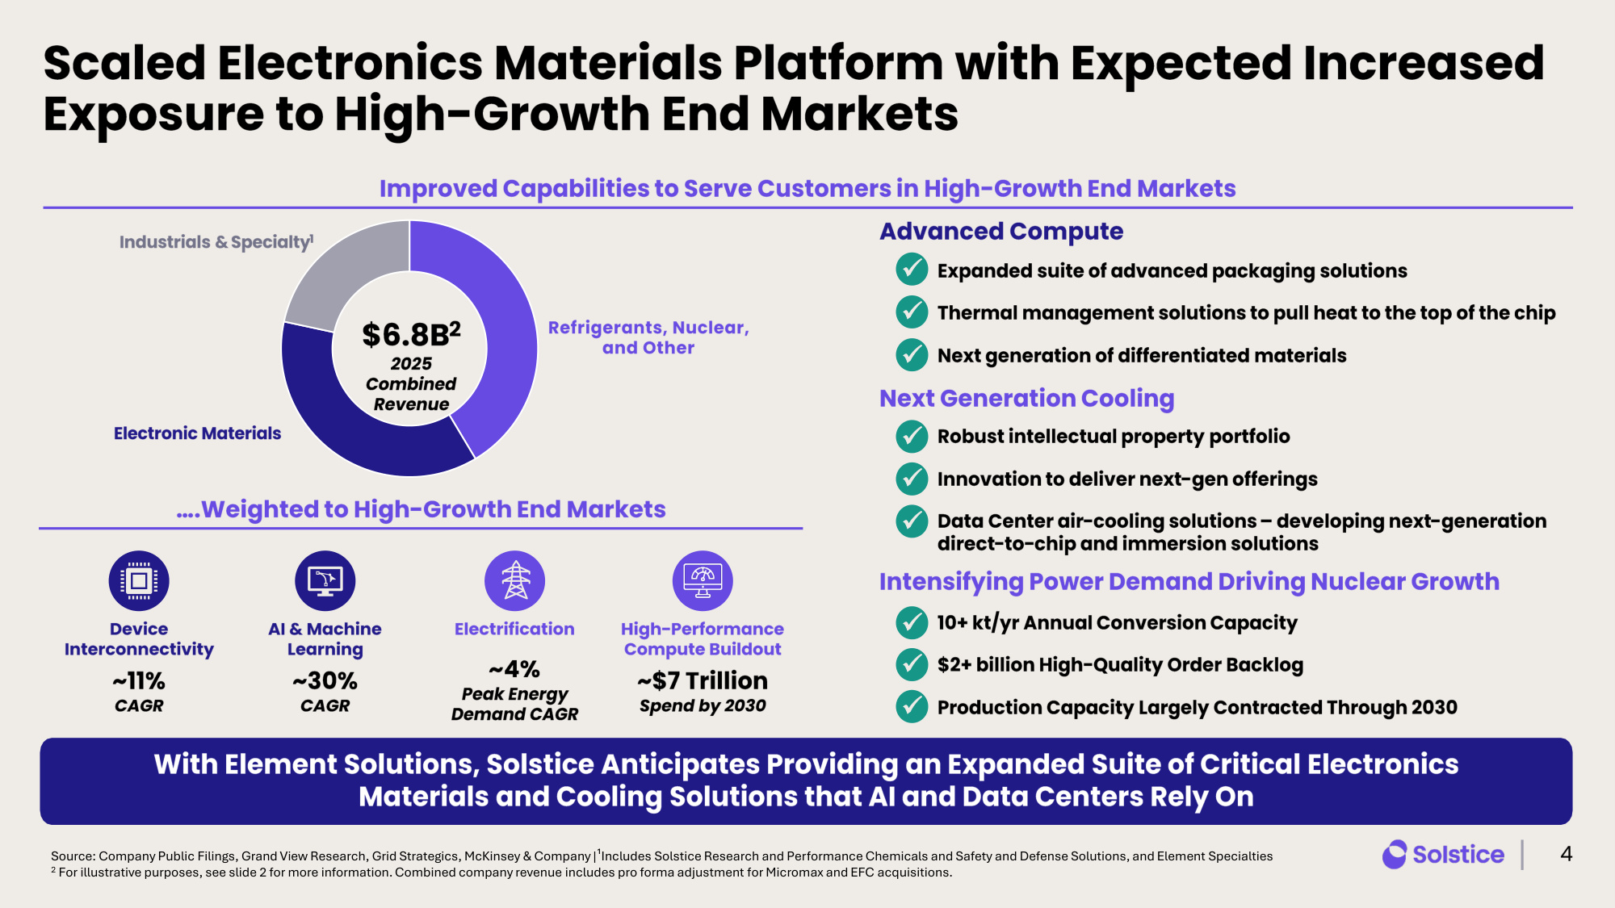
Scaled Electronics Materials Platform with Expected Increased Exposure to High - Growth End Markets 4 Source: Company Public Filings, Grand View Research, Grid Strategics, McKinsey & Company |¹Includes Solstice Research and Performance Chemicals and Safety and Defense Solutions, and Element Specialties 2 For illustrative purposes, see slide 2 for more information. Combined company revenue includes pro forma adjustment for Micromax and EFC acquisitions. Improved Capabilities to Serve Customers in High - Growth End Markets $6.8B 2 2025 Combined Revenue Electronic Materials Industrials & Specialty 1 Refrigerants, Nuclear, and Other Next Generation Cooling Intensifying Power Demand Driving Nuclear Growth Advanced Compute Expanded suite of advanced packaging solutions Thermal management solutions to pull heat to the top of the chip Next generation of differentiated materials ✓ ✓ ✓ Robust intellectual property portfolio Innovation to deliver next - gen offerings Data Center air - cooling solutions – developing next - generation direct - to - chip and immersion solutions ✓ ✓ ✓ 10+ kt/yr Annual Conversion Capacity $2+ billion High - Quality Order Backlog Production Capacity Largely Contracted Through 2030 ✓ ✓ ✓ With Element Solutions, Solstice Anticipates Providing an Expanded Suite of Critical Electronics Materials and Cooling Solutions that AI and Data Centers Rely On Device Interconnectivity AI & Machine Learning Electrification High - Performance Compute Buildout ~11% CAGR ~30% CAGR ~$7 Trillion Spend by 2030 ~4% Peak Energy Demand CAGR ....Weighted to High - Growth End Markets

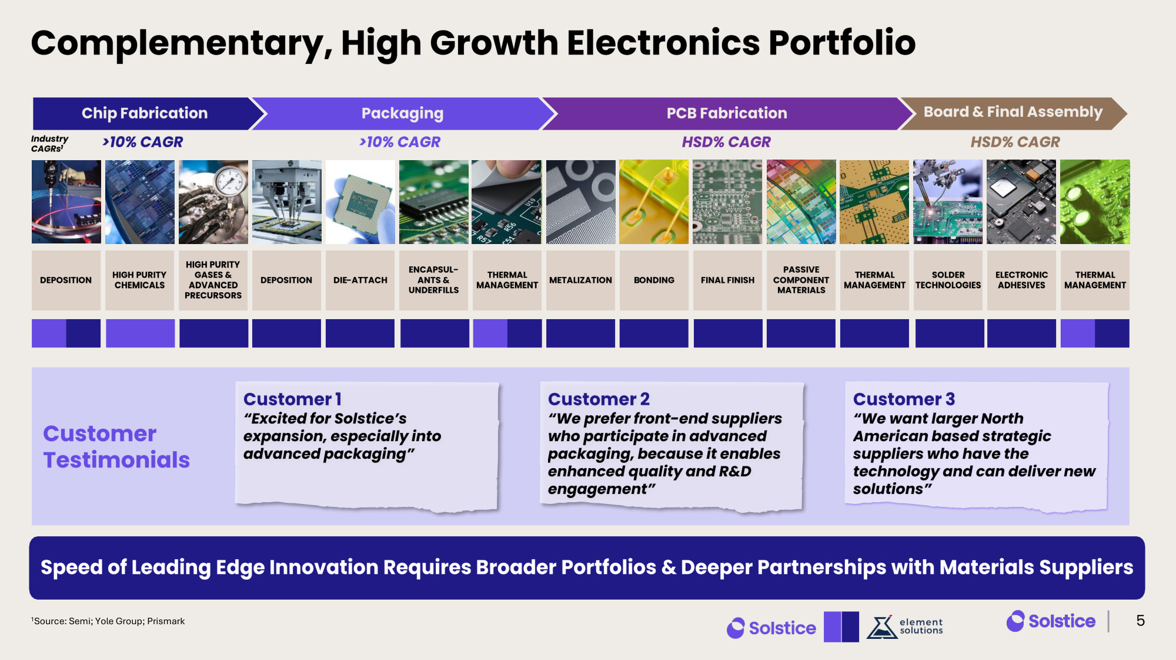
Chip Fabrication Packaging Complementary, High Growth Electronics Portfolio Complementary, High Growth Electronics Portfolio 5 Speed of Leading Edge Innovation Requires Broader Portfolios & Deeper Partnerships with Materials Suppliers PCB Fabrication Board & Final Assembly >10% CAGR >10% CAGR HSD% CAGR HSD% CAGR Customer 1 "Excited for Solstice's expansion, especially into advanced packaging" Customer 2 "We prefer front - end suppliers who participate in advanced packaging, because it enables enhanced quality and R&D engagement" Customer 3 "We want larger North American based strategic suppliers who have the technology and can deliver new solutions" Customer Testimonials 1Source: Semi; Yole Group; Prismark Industry CAGRs 1 DEPOSITION HIGH PURITY GASES & ADVANCED PRECURSORS HIGH PURITY CHEMICALS DEPOSITION ENCAPSUL - ANTS & UNDERFILLS DIE - ATTACH PASSIVE COMPONENT MATERIALS THERMAL MANAGEMENT THERMAL MANAGEMENT THERMAL MANAGEMENT METALIZATION TBU BONDING TBU FINAL FINISH SOLDER TECHNOLOGIES ELECTRONIC ADHESIVES TBU

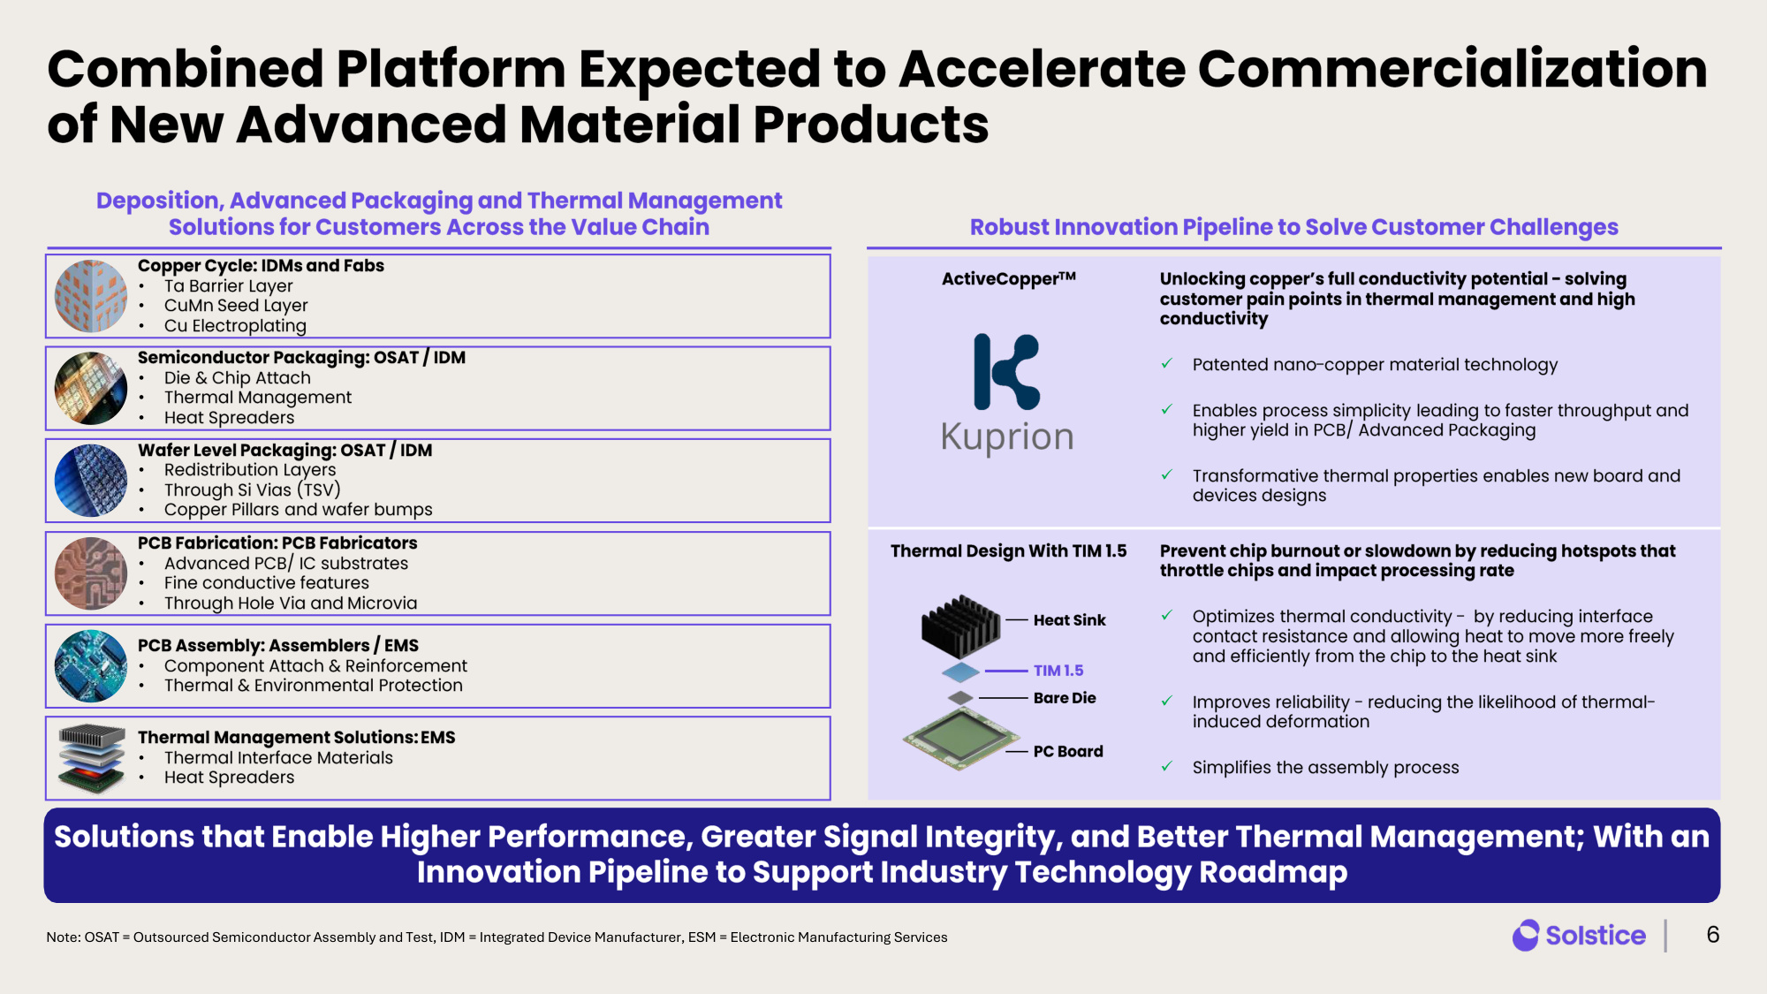
Combined Platform Expected to Accelerate Commercialization of New Advanced Material Products 6 Deposition, Advanced Packaging and Thermal Management Solutions for Customers Across the Value Chain Robust Innovation Pipeline to Solve Customer Challenges ActiveCopper TM Unlocking copper's full conductivity potential - solving customer pain points in thermal management and high conductivity ✓ Patented nano - copper material technology ✓ Enables process simplicity leading to faster throughput and higher yield in PCB/ Advanced Packaging ✓ Transformative thermal properties enables new board and devices designs Thermal Design With TIM 1.5 Prevent chip burnout or slowdown by reducing hotspots that throttle chips and impact processing rate ✓ Optimizes thermal conductivity - by reducing interface contact resistance and allowing heat to move more freely and efficiently from the chip to the heat sink ✓ Improves reliability - reducing the likelihood of thermal - induced deformation ✓ Simplifies the assembly process Heat Sink TIM 1.5 Bare Die PC Board Copper Cycle: IDMs and Fabs • Ta Barrier Layer • CuMn Seed Layer • Cu Electroplating PCB Assembly: Assemblers / EMS • Component Attach & Reinforcement • Thermal & Environmental Protection PCB Fabrication: PCB Fabricators • Advanced PCB/ IC substrates • Fine conductive features • Through Hole Via and Microvia Thermal Management Solutions: EMS • Thermal Interface Materials • Heat Spreaders Solutions that Enable Higher Performance, Greater Signal Integrity, and Better Thermal Management; With an Innovation Pipeline to Support Industry Technology Roadmap Semiconductor Packaging: OSAT / IDM • Die & Chip Attach • Thermal Management • Heat Spreaders Wafer Level Packaging: OSAT / IDM • Redistribution Layers • Through Si Vias (TSV) • Copper Pillars and wafer bumps Note: OSAT = Outsourced Semiconductor Assembly and Test, IDM = Integrated Device Manufacturer, ESM = Electronic Manufacturing Services

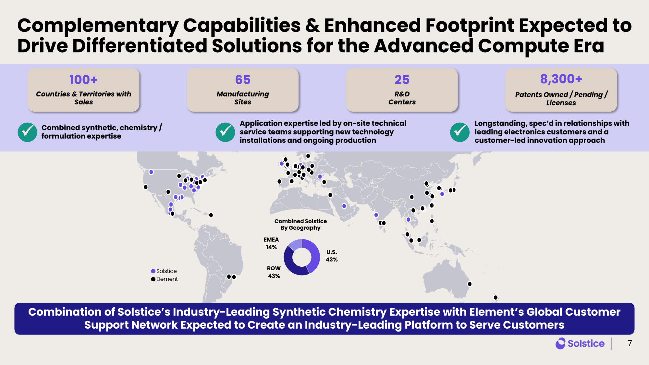
\\FIRMWIDE.CORP.GS.COM\IBDROOT\PROJECTS\IBD-NY\SMATTER2026\994051_1\_Graphics\MapInfo\01 Eclipse Solar Map\01 Eclipse Solar Map.WOR ⚫⚫⚫⚫⚫⚫⚫⚫⚫⚫⚫⚫⚫⚫⚫⚫⚫⚫⚫⚫⚫⚫⚫⚫⚫⚫⚫⚫⚫⚫⚫⚫⚫⚫⚫⚫⚫⚫⚫⚫⚫⚫ ⚫⚫⚫⚫⚫⚫⚫⚫⚫⚫⚫⚫⚫⚫⚫⚫⚫⚫⚫⚫⚫⚫⚫⚫⚫⚫⚫⚫⚫⚫⚫⚫⚫⚫⚫⚫⚫⚫⚫⚫⚫⚫ ⚫⚫⚫⚫⚫⚫⚫⚫⚫⚫⚫⚫⚫⚫⚫⚫⚫⚫⚫⚫⚫ ⚫⚫⚫⚫⚫⚫⚫⚫⚫⚫⚫⚫⚫⚫⚫⚫⚫⚫⚫⚫⚫ ⚫⚫⚫⚫⚫⚫⚫⚫⚫⚫⚫⚫⚫⚫⚫⚫⚫⚫⚫⚫⚫ ⚫⚫⚫⚫⚫⚫⚫⚫⚫⚫⚫⚫⚫⚫⚫⚫⚫⚫⚫⚫⚫ ⚫⚫⚫⚫⚫⚫⚫⚫⚫⚫⚫⚫⚫⚫⚫⚫⚫⚫⚫⚫⚫ ⚫⚫⚫⚫⚫⚫⚫⚫⚫⚫⚫⚫⚫⚫⚫⚫⚫⚫⚫⚫⚫ ⚫⚫⚫⚫⚫⚫⚫⚫⚫⚫⚫⚫⚫⚫⚫⚫⚫⚫⚫⚫⚫ ⚫⚫⚫⚫⚫⚫⚫⚫⚫⚫⚫⚫⚫⚫⚫⚫⚫⚫⚫⚫⚫⚫⚫⚫⚫⚫⚫⚫⚫⚫⚫⚫⚫⚫⚫⚫⚫⚫⚫⚫⚫⚫ ⚫⚫⚫⚫⚫⚫⚫⚫⚫⚫⚫⚫⚫⚫⚫⚫⚫⚫⚫⚫⚫ ⚫⚫⚫⚫⚫⚫⚫⚫⚫⚫⚫⚫⚫⚫⚫⚫⚫⚫⚫⚫⚫ ⚫⚫⚫⚫⚫⚫⚫⚫⚫⚫⚫⚫⚫⚫⚫⚫⚫⚫⚫⚫⚫ ⚫⚫⚫⚫⚫⚫⚫⚫⚫⚫⚫⚫⚫⚫⚫⚫⚫⚫⚫⚫⚫ ⚫⚫⚫⚫⚫⚫⚫⚫⚫⚫⚫⚫⚫⚫⚫⚫⚫⚫⚫⚫⚫ ⚫⚫⚫⚫⚫⚫⚫⚫⚫⚫⚫⚫⚫⚫⚫⚫⚫⚫⚫⚫⚫ ⚫⚫⚫⚫⚫⚫⚫⚫⚫⚫⚫⚫⚫⚫⚫⚫⚫⚫⚫⚫⚫ ⚫⚫⚫⚫⚫⚫⚫⚫⚫⚫⚫⚫⚫⚫⚫⚫⚫⚫⚫⚫⚫ ⚫⚫⚫⚫⚫⚫⚫⚫⚫⚫⚫⚫⚫⚫⚫⚫⚫⚫⚫⚫⚫ ⚫⚫⚫⚫⚫⚫⚫⚫⚫⚫⚫⚫⚫⚫⚫⚫⚫⚫⚫⚫⚫ ⚫⚫⚫⚫⚫⚫⚫⚫⚫⚫⚫⚫⚫⚫⚫⚫⚫⚫⚫⚫⚫ ⚫⚫⚫⚫⚫⚫⚫⚫⚫⚫⚫⚫⚫⚫⚫⚫⚫⚫⚫⚫⚫⚫⚫⚫⚫⚫⚫⚫⚫⚫⚫⚫⚫⚫⚫⚫⚫⚫⚫⚫⚫⚫ ⚫⚫⚫⚫⚫⚫⚫⚫⚫⚫⚫⚫⚫⚫⚫⚫⚫⚫⚫⚫⚫ ⚫⚫⚫⚫⚫⚫⚫⚫⚫⚫⚫⚫⚫⚫⚫⚫⚫⚫⚫⚫⚫ ⚫⚫⚫⚫⚫⚫⚫⚫⚫⚫⚫⚫⚫⚫⚫⚫⚫⚫⚫⚫⚫ ⚫⚫⚫⚫⚫⚫⚫⚫⚫⚫⚫⚫⚫⚫⚫⚫⚫⚫⚫⚫⚫ ⚫⚫⚫⚫⚫⚫⚫⚫⚫⚫⚫⚫⚫⚫⚫⚫⚫⚫⚫⚫⚫⚫⚫⚫⚫⚫⚫⚫⚫⚫⚫⚫⚫⚫⚫⚫⚫⚫⚫⚫⚫⚫ ⚫⚫⚫⚫⚫⚫⚫⚫⚫⚫⚫⚫⚫⚫⚫⚫⚫⚫⚫⚫⚫ ⚫⚫⚫⚫⚫⚫⚫⚫⚫⚫⚫⚫⚫⚫⚫⚫⚫⚫⚫⚫⚫⚫⚫⚫⚫⚫⚫⚫⚫⚫⚫⚫⚫⚫⚫⚫⚫⚫⚫⚫⚫⚫⚫⚫⚫⚫⚫⚫⚫⚫⚫⚫⚫⚫⚫⚫⚫⚫⚫⚫⚫⚫⚫ ⚫⚫⚫⚫⚫⚫⚫⚫⚫⚫⚫⚫⚫⚫⚫⚫⚫⚫⚫⚫⚫ ⚫⚫⚫⚫⚫⚫⚫⚫⚫⚫⚫⚫⚫⚫⚫⚫⚫⚫⚫⚫⚫ ⚫⚫⚫⚫⚫⚫⚫⚫⚫⚫⚫⚫⚫⚫⚫⚫⚫⚫⚫⚫⚫ ⚫⚫⚫⚫⚫⚫⚫⚫⚫⚫⚫⚫⚫⚫⚫⚫⚫⚫⚫⚫⚫ ⚫⚫⚫⚫⚫⚫⚫⚫⚫⚫⚫⚫⚫⚫⚫⚫⚫⚫⚫⚫⚫⚫⚫⚫⚫⚫⚫⚫⚫⚫⚫⚫⚫⚫⚫⚫⚫⚫⚫⚫⚫⚫⚫⚫⚫⚫⚫⚫⚫⚫⚫⚫⚫⚫⚫⚫⚫⚫⚫⚫⚫⚫⚫ ⚫⚫⚫⚫⚫⚫⚫⚫⚫⚫⚫⚫⚫⚫⚫⚫⚫⚫⚫⚫⚫ ⚫⚫⚫⚫⚫⚫⚫⚫⚫⚫⚫⚫⚫⚫⚫⚫⚫⚫⚫⚫⚫ ⚫⚫⚫⚫⚫⚫⚫⚫⚫⚫⚫⚫⚫⚫⚫⚫⚫⚫⚫⚫⚫ ⚫⚫⚫⚫⚫⚫⚫⚫⚫⚫⚫⚫⚫⚫⚫⚫⚫⚫⚫⚫⚫ ⚫⚫⚫⚫⚫⚫⚫⚫⚫⚫⚫⚫⚫⚫⚫⚫⚫⚫⚫⚫⚫ ⚫⚫⚫⚫⚫⚫⚫⚫⚫⚫⚫⚫⚫⚫⚫⚫⚫⚫⚫⚫⚫⚫⚫⚫⚫⚫⚫⚫⚫⚫⚫⚫⚫⚫⚫⚫⚫⚫⚫⚫⚫⚫ ⚫⚫⚫⚫⚫⚫⚫⚫⚫⚫⚫⚫⚫⚫⚫⚫⚫⚫⚫⚫⚫ ⚫⚫⚫⚫⚫⚫⚫⚫⚫⚫⚫⚫⚫⚫⚫⚫⚫⚫⚫⚫⚫ ⚫⚫⚫⚫⚫⚫⚫⚫⚫⚫⚫⚫⚫⚫⚫⚫⚫⚫⚫⚫⚫⚫⚫⚫⚫⚫⚫⚫⚫⚫⚫⚫⚫⚫⚫⚫⚫⚫⚫⚫⚫⚫ ⚫⚫⚫⚫⚫⚫⚫⚫⚫⚫⚫⚫⚫⚫⚫⚫⚫⚫⚫⚫⚫ ⚫⚫⚫⚫⚫⚫⚫⚫⚫⚫⚫⚫⚫⚫⚫⚫⚫⚫⚫⚫⚫ ⚫⚫⚫⚫⚫⚫⚫⚫⚫⚫⚫⚫⚫⚫⚫⚫⚫⚫⚫⚫⚫ ⚫⚫⚫⚫⚫⚫⚫⚫⚫⚫⚫⚫⚫⚫⚫⚫⚫⚫⚫⚫⚫ ⚫⚫⚫⚫⚫⚫⚫⚫⚫⚫⚫⚫⚫⚫⚫⚫⚫⚫⚫⚫⚫ ⚫⚫⚫⚫⚫⚫⚫⚫⚫⚫⚫⚫⚫⚫⚫⚫⚫⚫⚫⚫⚫⚫⚫⚫⚫⚫⚫⚫⚫⚫⚫⚫⚫⚫⚫⚫⚫⚫⚫⚫⚫⚫ ⚫⚫⚫⚫⚫⚫⚫⚫⚫⚫⚫⚫⚫⚫⚫⚫⚫⚫⚫⚫⚫ ⚫⚫⚫⚫⚫⚫⚫⚫⚫⚫⚫⚫⚫⚫⚫⚫⚫⚫⚫⚫⚫ ⚫⚫⚫⚫⚫⚫⚫⚫⚫⚫⚫⚫⚫⚫⚫⚫⚫⚫⚫⚫⚫ ⚫⚫⚫⚫⚫⚫⚫⚫⚫⚫⚫⚫⚫⚫⚫⚫⚫⚫⚫⚫⚫⚫⚫⚫⚫⚫⚫⚫⚫⚫⚫⚫⚫⚫⚫⚫⚫⚫⚫⚫⚫⚫⚫⚫⚫⚫⚫⚫⚫⚫⚫⚫⚫⚫⚫⚫⚫⚫⚫⚫⚫⚫⚫ ⚫⚫⚫⚫⚫⚫⚫⚫⚫⚫⚫⚫⚫⚫⚫⚫⚫⚫⚫⚫⚫ ⚫⚫⚫⚫⚫⚫⚫⚫⚫⚫⚫⚫⚫⚫⚫⚫⚫⚫⚫⚫⚫ ⚫⚫⚫⚫⚫⚫⚫⚫⚫⚫⚫⚫⚫⚫⚫⚫⚫⚫⚫⚫⚫⚫⚫⚫⚫⚫⚫⚫⚫⚫⚫⚫⚫⚫⚫⚫⚫⚫⚫⚫⚫⚫ ⚫⚫⚫⚫⚫⚫⚫⚫⚫⚫⚫⚫⚫⚫⚫⚫⚫⚫⚫⚫⚫ ⚫⚫⚫⚫⚫⚫⚫⚫⚫⚫⚫⚫⚫⚫⚫⚫⚫⚫⚫⚫⚫⚫⚫⚫⚫⚫⚫⚫⚫⚫⚫⚫⚫⚫⚫⚫⚫⚫⚫⚫⚫⚫⚫⚫⚫⚫⚫⚫⚫⚫⚫⚫⚫⚫⚫⚫⚫⚫⚫⚫⚫⚫ ⚫⚫⚫⚫⚫⚫⚫⚫⚫⚫⚫⚫⚫⚫⚫⚫⚫⚫⚫⚫⚫ ⚫⚫⚫⚫⚫⚫⚫⚫⚫⚫⚫⚫⚫⚫⚫⚫⚫⚫⚫⚫⚫ ⚫⚫⚫⚫⚫⚫⚫⚫⚫⚫⚫⚫⚫⚫⚫⚫⚫⚫⚫⚫⚫ ⚫⚫⚫⚫⚫⚫⚫⚫⚫⚫⚫⚫⚫⚫⚫⚫⚫⚫⚫⚫⚫⚫⚫⚫⚫⚫⚫⚫⚫⚫⚫⚫⚫⚫⚫⚫⚫⚫⚫⚫⚫⚫⚫⚫⚫⚫⚫⚫⚫⚫⚫⚫⚫⚫⚫⚫⚫⚫⚫⚫⚫⚫⚫ ⚫⚫⚫⚫⚫⚫⚫⚫⚫⚫⚫⚫⚫⚫⚫⚫⚫⚫⚫⚫⚫⚫⚫⚫⚫⚫⚫⚫⚫⚫⚫⚫⚫⚫⚫⚫⚫⚫⚫⚫⚫⚫ ⚫⚫⚫⚫⚫⚫⚫⚫⚫⚫⚫⚫⚫⚫⚫⚫⚫⚫⚫⚫⚫ ⚫⚫⚫⚫⚫⚫⚫⚫⚫⚫⚫⚫⚫⚫⚫⚫⚫⚫⚫⚫⚫ ⚫⚫⚫⚫⚫⚫⚫⚫⚫⚫⚫⚫⚫⚫⚫⚫⚫⚫⚫⚫⚫ ⚫⚫⚫⚫⚫⚫⚫⚫⚫⚫⚫⚫⚫⚫⚫⚫⚫⚫⚫⚫⚫ ⚫⚫⚫⚫⚫⚫⚫⚫⚫⚫⚫⚫⚫⚫⚫⚫⚫⚫⚫⚫⚫ ⚫⚫⚫⚫⚫⚫⚫⚫⚫⚫⚫⚫⚫⚫⚫⚫⚫⚫⚫⚫⚫ ⚫⚫⚫⚫⚫⚫⚫⚫⚫⚫⚫⚫⚫⚫⚫⚫⚫⚫⚫⚫⚫⚫⚫⚫⚫⚫⚫⚫⚫⚫⚫⚫⚫⚫⚫⚫⚫⚫⚫⚫⚫⚫ ⚫⚫⚫⚫⚫⚫⚫⚫⚫⚫⚫⚫⚫⚫⚫⚫⚫⚫⚫⚫⚫⚫⚫⚫⚫⚫⚫⚫⚫⚫⚫⚫⚫⚫⚫⚫⚫⚫⚫⚫⚫⚫ ⚫⚫⚫⚫⚫⚫⚫⚫⚫⚫⚫⚫⚫⚫⚫⚫⚫⚫⚫⚫⚫⚫⚫⚫⚫⚫⚫⚫⚫⚫⚫⚫⚫⚫⚫⚫⚫⚫⚫⚫⚫⚫ ⚫⚫⚫⚫⚫⚫⚫⚫⚫⚫⚫⚫⚫⚫⚫⚫⚫⚫⚫⚫⚫ ⚫⚫⚫⚫⚫⚫⚫⚫⚫⚫⚫⚫⚫⚫⚫⚫⚫⚫⚫⚫⚫⚫⚫⚫⚫⚫⚫⚫⚫⚫⚫⚫⚫⚫⚫⚫⚫⚫⚫⚫⚫⚫ ⚫⚫⚫⚫⚫⚫⚫⚫⚫⚫⚫⚫⚫⚫⚫⚫⚫⚫⚫⚫⚫⚫⚫⚫⚫⚫⚫⚫⚫⚫⚫⚫⚫⚫⚫⚫⚫⚫⚫⚫⚫⚫⚫⚫⚫⚫⚫⚫⚫⚫⚫⚫⚫⚫⚫⚫⚫⚫⚫⚫⚫⚫ ⚫⚫⚫⚫⚫⚫⚫⚫⚫⚫⚫⚫⚫⚫⚫⚫⚫⚫⚫⚫⚫ ⚫⚫⚫⚫⚫⚫⚫⚫⚫⚫⚫⚫⚫⚫⚫⚫⚫⚫⚫⚫⚫ ⚫⚫⚫⚫⚫⚫⚫⚫⚫⚫⚫⚫⚫⚫⚫⚫⚫⚫⚫⚫⚫ ⚫⚫⚫⚫⚫⚫⚫⚫⚫⚫⚫⚫⚫⚫⚫⚫⚫⚫⚫⚫⚫ ⚫⚫⚫⚫⚫⚫⚫⚫⚫⚫⚫⚫⚫⚫⚫⚫⚫⚫⚫⚫⚫ ⚫⚫⚫⚫⚫⚫⚫⚫⚫⚫⚫⚫⚫⚫⚫⚫⚫⚫⚫⚫⚫⚫⚫⚫⚫⚫⚫⚫⚫⚫⚫⚫⚫⚫⚫⚫⚫⚫⚫⚫⚫⚫ ⚫⚫⚫⚫⚫⚫⚫⚫⚫⚫⚫⚫⚫⚫⚫⚫⚫⚫⚫⚫⚫ ⚫⚫⚫⚫⚫⚫⚫⚫⚫⚫⚫⚫⚫⚫⚫⚫⚫⚫⚫⚫⚫⚫⚫⚫⚫⚫⚫⚫⚫⚫⚫⚫⚫⚫⚫⚫⚫⚫⚫⚫⚫⚫ ⚫⚫⚫⚫⚫⚫⚫⚫⚫⚫⚫⚫⚫⚫⚫⚫⚫⚫⚫⚫⚫ ⚫⚫⚫⚫⚫⚫⚫⚫⚫⚫⚫⚫⚫⚫⚫⚫⚫⚫⚫⚫⚫⚫⚫⚫⚫⚫⚫⚫⚫⚫⚫⚫⚫⚫⚫⚫⚫⚫⚫⚫⚫ ⚫⚫⚫⚫⚫⚫⚫⚫⚫⚫⚫⚫⚫⚫⚫⚫⚫⚫⚫⚫⚫ ⚫⚫⚫⚫⚫⚫⚫⚫⚫⚫⚫⚫⚫⚫⚫⚫⚫⚫⚫⚫⚫ ⚫⚫⚫⚫⚫⚫⚫⚫⚫⚫⚫⚫⚫⚫⚫⚫⚫⚫⚫⚫⚫ ⚫⚫⚫⚫⚫⚫⚫⚫⚫⚫⚫⚫⚫⚫⚫⚫⚫⚫⚫⚫⚫ ⚫⚫⚫⚫⚫⚫⚫⚫⚫⚫⚫⚫⚫⚫⚫⚫⚫⚫⚫⚫⚫ ⚫⚫⚫⚫⚫⚫⚫⚫⚫⚫⚫⚫⚫⚫⚫⚫⚫⚫⚫⚫⚫⚫⚫⚫⚫⚫⚫⚫⚫⚫⚫⚫⚫⚫⚫⚫⚫⚫⚫⚫⚫⚫⚫⚫⚫⚫⚫⚫⚫⚫⚫⚫⚫⚫⚫⚫⚫⚫⚫⚫⚫⚫⚫ ⚫⚫⚫⚫⚫⚫⚫⚫⚫⚫⚫⚫⚫⚫⚫⚫⚫⚫⚫⚫⚫ ⚫⚫⚫⚫⚫⚫⚫⚫⚫⚫⚫⚫⚫⚫⚫⚫⚫⚫⚫⚫⚫ ⚫⚫⚫⚫⚫⚫⚫⚫⚫⚫⚫⚫⚫⚫⚫⚫⚫⚫⚫⚫⚫⚫⚫⚫⚫⚫⚫⚫⚫⚫⚫⚫⚫⚫⚫⚫⚫⚫⚫⚫⚫⚫⚫⚫⚫⚫⚫⚫⚫⚫⚫⚫⚫⚫⚫⚫⚫⚫⚫⚫⚫⚫⚫ ⚫⚫⚫⚫⚫⚫⚫⚫⚫⚫⚫⚫⚫⚫⚫⚫⚫⚫⚫⚫⚫ Complementary Capabilities & Enhanced Footprint Expected to Drive Differentiated Solutions for the Advanced Compute Era 7 65 Manufacturing Sites 100+ Countries & Territories with Sales 25 R&D Centers Combination of Solstice's Industry - Leading Synthetic Chemistry Expertise with Element's Global Customer Support Network Expected to Create an Industry - Leading Platform to Serve Customers 8,300+ Patents Owned / Pending / Licenses ✓ Combined synthetic, chemistry / formulation expertise ✓ Longstanding, spec'd in relationships with leading electronics customers and a customer - led innovation approach ✓ Application expertise led by on - site technical service teams supporting new technology installations and ongoing production Solstice Element Combined Solstice By Geography U.S. 43% ROW 43% EMEA 14%

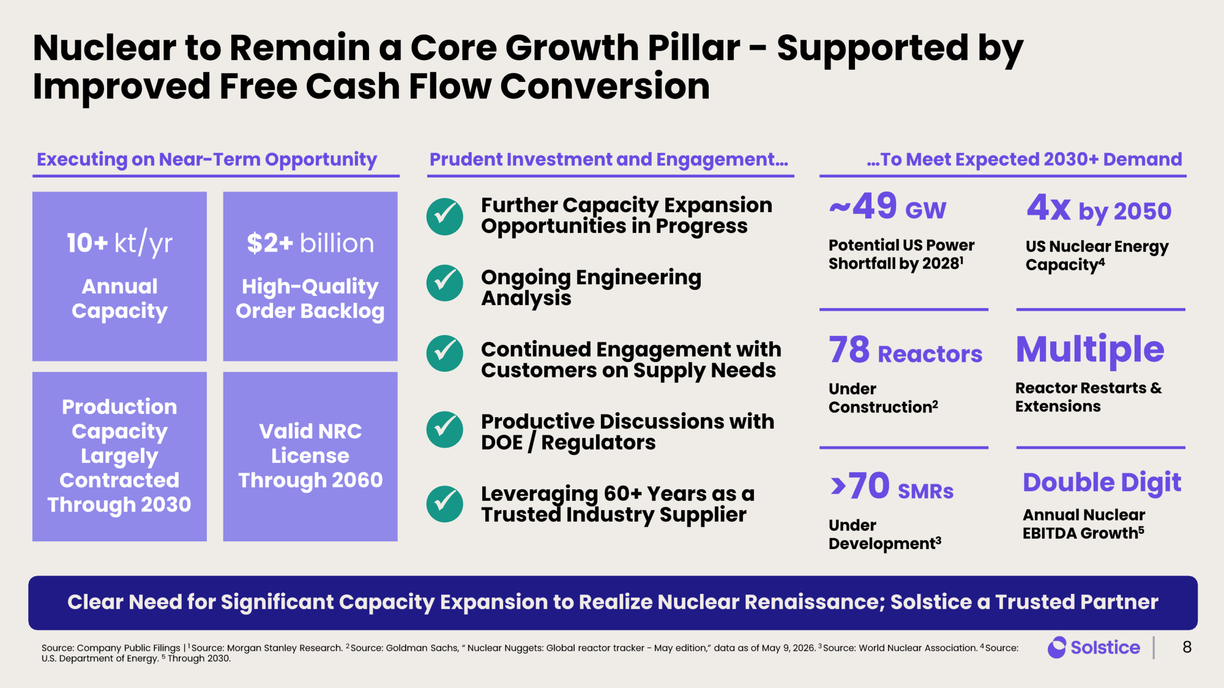
Nuclear to Remain a Core Growth Pillar - Supported by Improved Free Cash Flow Conversion 8 Source: Company Public Filings | 1 Source: Morgan Stanley Research. 2 Source: Goldman Sachs, " Nuclear Nuggets: Global reactor tracker - May edition," data as of May 9, 2026. 3 Source: World Nuclear Association. 4 Source: U.S. Department of Energy. 5 Through 2030. Clear Need for Significant Capacity Expansion to Realize Nuclear Renaissance; Solstice a Trusted Partner Executing on Near - Term Opportunity Prudent Investment and Engagement... $2+ billion High - Quality Order Backlog Valid NRC License Through 2060 10+ kt/yr Annual Capacity Further Capacity Expansion Opportunities in Progress Ongoing Engineering Analysis Continued Engagement with Customers on Supply Needs Productive Discussions with DOE / Regulators Leveraging 60+ Years as a Trusted Industry Supplier Production Capacity Largely Contracted Through 2030 ✓ ✓ ✓ ✓ >70 SMRs Under Development 3 Double Digit Annual Nuclear EBITDA Growth 5 ~49 GW Potential US Power Shortfall by 2028 1 4x by 2050 US Nuclear Energy Capacity 4 Multiple Reactor Restarts & Extensions 78 Reactors Under Construction 2 ...To Meet Expected 2030+ Demand ✓

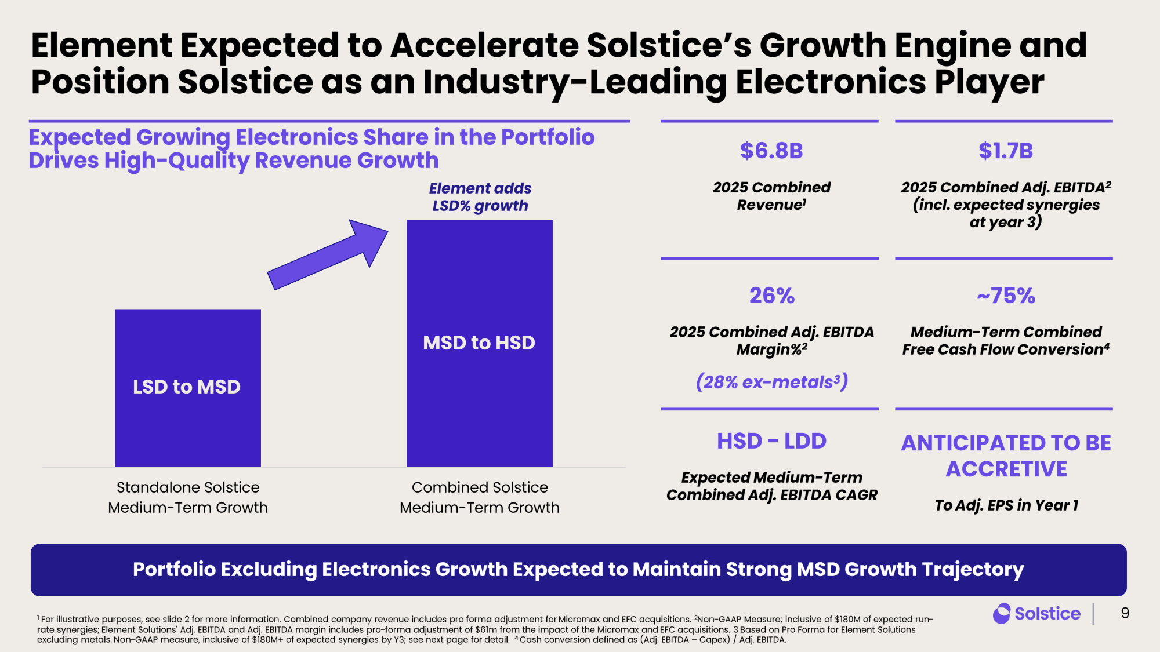
Element Expected to Accelerate Solstice's Growth Engine and Position Solstice as an Industry - Leading Electronics Player 9 $6.8B 2025 Combined Revenue 1 $1.7B 2025 Combined Adj. EBITDA 2 (incl. expected synergies at year 3 ) 26% 2025 Combined Adj. EBITDA Margin% 2 (28% ex - metals 3) HSD - LDD Expected Medium - Term Combined Adj. EBITDA CAGR ANTICIPATED TO BE ACCRETIVE To Adj. EPS in Year 1 ~75% Medium - Term Combined Free Cash Flow Conversion 4 Portfolio Excluding Electronics Growth Expected to Maintain Strong MSD Growth Trajectory Expected Growing Electronics Share in the Portfolio Drives High - Quality Revenue Growth Standalone Solstice Medium-Term Growth Combined Solstice Medium-Term Growth Element adds LSD% growth LSD to MSD MSD to HSD 1 For illustrative purposes, see slide 2 for more information. Combined company revenue includes pro forma adjustment for Micromax and EFC acquisitions. 2Non - GAAP Measure; inclusive of $180M of expected run - rate synergies; Element Solutions' Adj. EBITDA and Adj. EBITDA margin includes pro - forma adjustment of $61m from the impact of the Micromax and EFC acquisitions. 3 Based on Pro Forma for Element Solutions excluding metals. Non - GAAP measure, inclusive of $180M+ of expected synergies by Y3; see next page for detail. 4 Cash conversion defined as (Adj. EBITDA – Capex) / Adj. EBITDA.

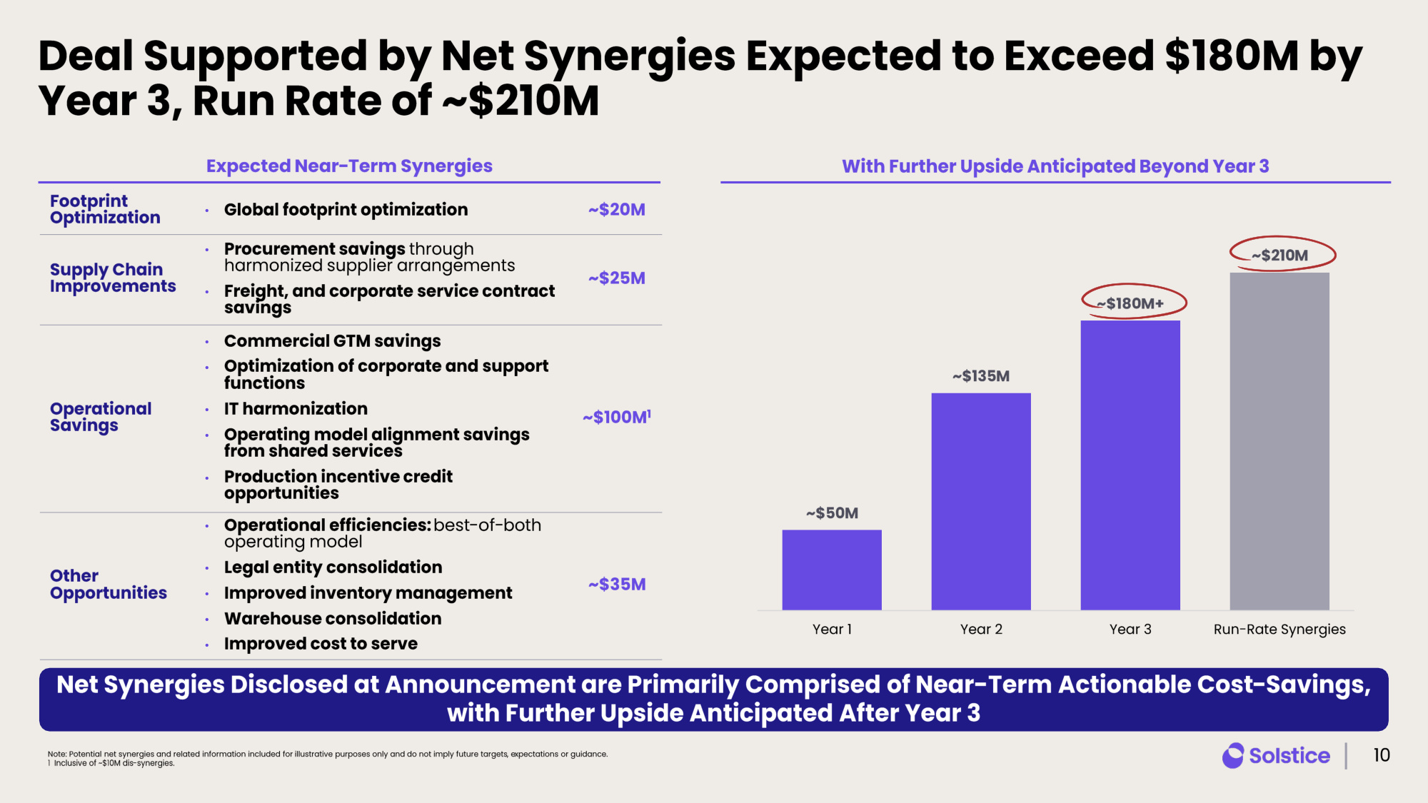
~$50 M ~$135 M ~$180 M+ ~$210 M Year 1 Year 2 Year 3 Run-Rate Synergies Deal Supported by Net Synergies Expected to Exceed $180M by Year 3, Run Rate of ~$210M 10 Footprint Optimization • Global footprint optimization ~$20M Supply Chain Improvements • Procurement savings through harmonized supplier arrangements • Freight, and corporate service contract savings ~$25M Operational Savings • Commercial GTM savings • Optimization of corporate and support functions • IT harmonization • Operating model alignment savings from shared services • Production incentive credit opportunities ~$100M 1 Other Opportunities • Operational efficiencies: best - of- both operating model • Legal entity consolidation • Improved inventory management • Warehouse consolidation • Improved cost to serve ~$35M Expected Near - Term Synergies With Further Upside Anticipated Beyond Year 3 Net Synergies Disclosed at Announcement are Primarily Comprised of Near - Term Actionable Cost - Savings, with Further Upside Anticipated After Year 3 Note: Potential net synergies and related information included for illustrative purposes only and do not imply future targets , expectations or guidance. 1 Inclusive of ~$10M dis - synergies.

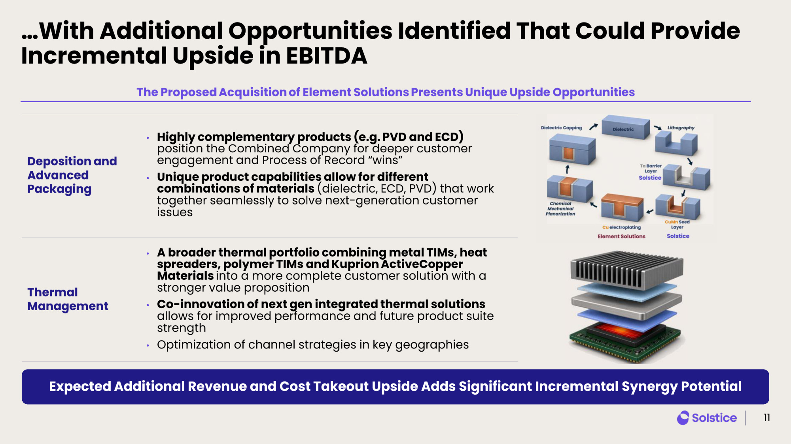
Deposition and Advanced Packaging • Highly complementary products ( e.g. PVD and ECD) position the Combined Company for deeper customer engagement and Process of Record "wins" • Unique product capabilities allow for different combinations of materials (dielectric, ECD, PVD) that work together seamlessly to solve next - generation customer issues Thermal Management • A broader thermal portfolio combining metal TIMs, heat spreaders, polymer TIMs and Kuprion ActiveCopper Materials into a more complete customer solution with a stronger value proposition • Co - innovation of next gen integrated thermal solutions allows for improved performance and future product suite strength • Optimization of channel strategies in key geographies The Proposed Acquisition of Element Solutions Presents Unique Upside Opportunities ...With Additional Opportunities Identified That Could Provide Incremental Upside in EBITDA 11 Expected Additional Revenue and Cost Takeout Upside Adds Significant Incremental Synergy Potential

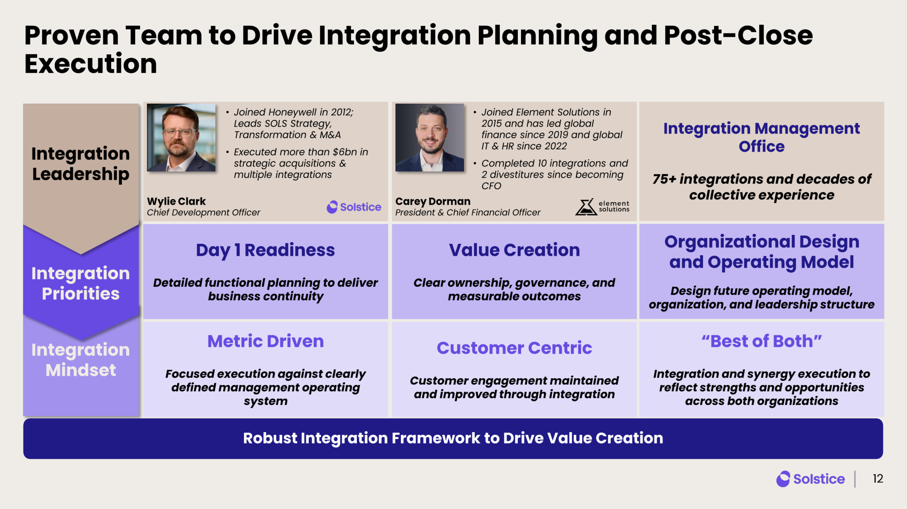
Integration Mindset Proven Team to Drive Integration Planning and Post - Close Execution Robust Integration Framework to Drive Value Creation 12 Metric Driven Focused execution against clearly defined management operating system Customer Centric Customer engagement maintained and improved through integration "Best of Both" Integration and synergy execution to reflect strengths and opportunities across both organizations Day 1 Readiness Detailed functional planning to deliver business continuity Value Creation Clear ownership, governance, and measurable outcomes Organizational Design and Operating Model Design future operating model, organization, and leadership structure Integration Priorities Integration Leadership Wylie Clark Chief Development Officer • Joined Honeywell in 2012; Leads SOLS Strategy, Transformation & M&A • Executed more than $6bn in strategic acquisitions & multiple integrations Carey Dorman President & Chief Financial Officer • Joined Element Solutions in 2015 and has led global finance since 2019 and global IT & HR since 2022 • Completed 10 integrations and 2 divestitures since becoming CFO Integration Management Office 75+ integrations and decades of collective experience

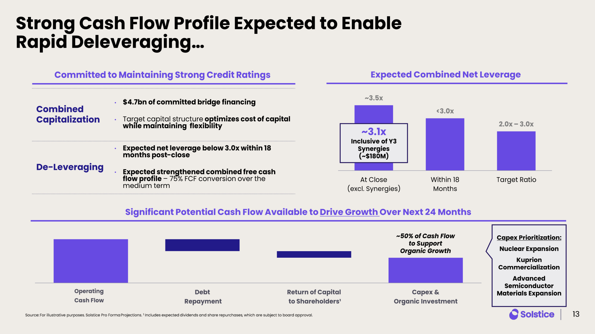
~3.5x <3.0x 2.0x – 3.0x At Close (excl. Synergies) Within 18 Months Target Ratio Committed to Maintaining Strong Credit Ratings Expected Combined Net Leverage Combined Capitalization • $4.7bn of committed bridge financing • Target capital structure optimizes cost of capital while maintaining flexibility De - Leveraging • Expected net leverage below 3.0x within 18 months post - close • Expected strengthened combined free cash flow profile – 75% FCF conversion over the medium term Significant Potential Cash Flow Available to Drive Growth Over Next 24 Months Cash Flow Debt Repayment Return of Capital to Shareholders¹ Capex & Organic Investment ~50% of Cash Flow to Support Organic Growth Source: For illustrative purposes. Solstice Pro Forma Projections. 1 Includes expected dividends and share repurchases , which are subject to board approval . Capex Prioritization: Nuclear Expansion Kuprion Commercialization Advanced Semiconductor Materials Expansion Strong Cash Flow Profile Expected to Enable Rapid Deleveraging... ~3.1x Inclusive of Y3 Synergies (~$180M) 13 Operating Cash Flow

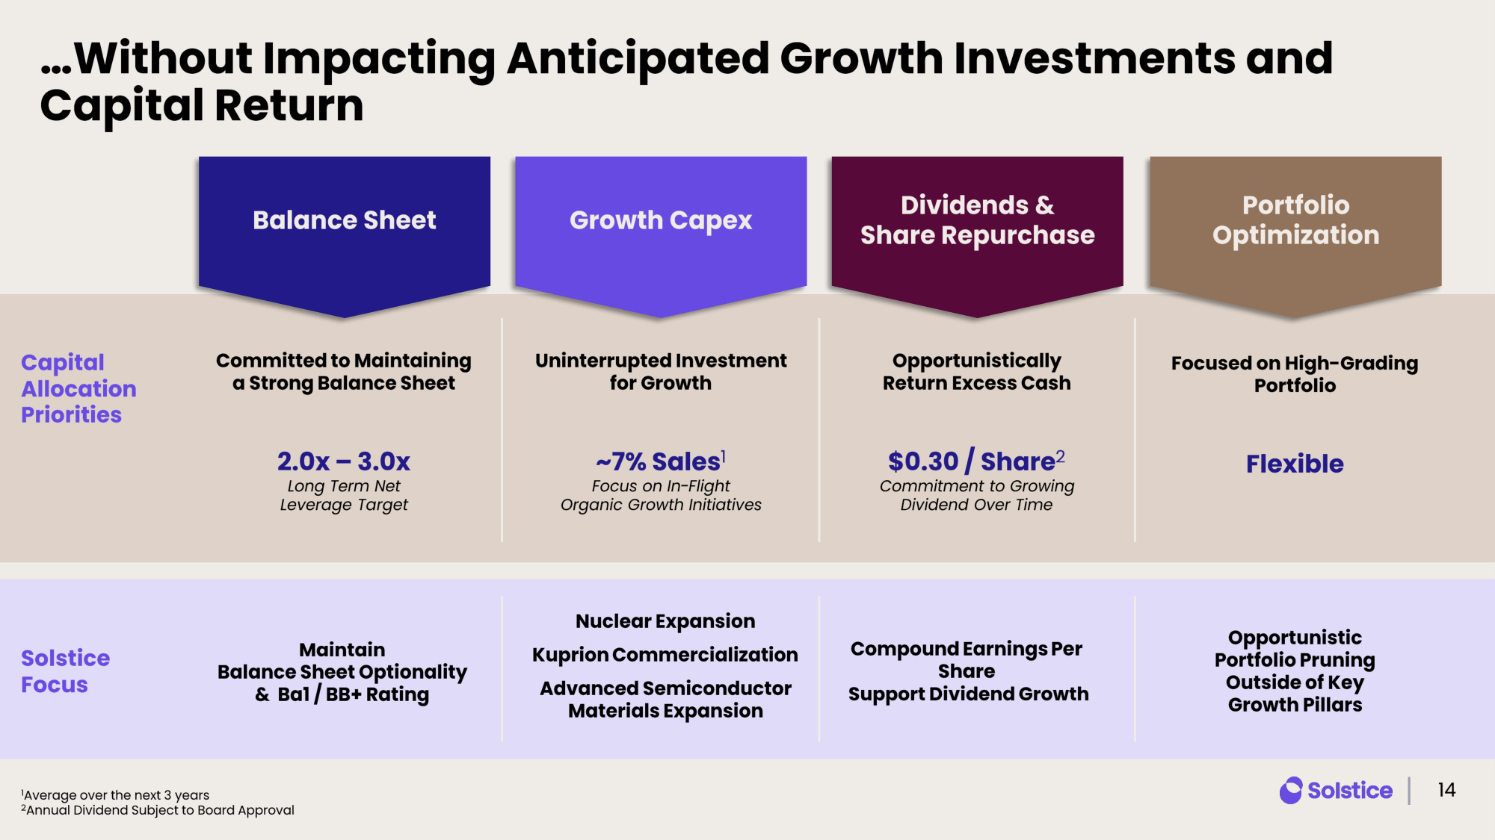
Capital Allocation Priorities Solstice Focus Balance Sheet Maintain Balance Sheet Optionality & Ba1 / BB+ Rating Committed to Maintaining a Strong Balance Sheet 2.0x – 3.0x Long Term Net Leverage Target Growth Capex Nuclear Expansion Kuprion Commercialization Advanced Semiconductor Materials Expansion Uninterrupted Investment for Growth ~7% Sales 1 Focus on In - Flight Organic Growth Initiatives Dividends & Share Repurchase Compound Earnings Per Share Support Dividend Growth Opportunistically Return Excess Cash $0.30 / Share 2 Commitment to Growing Dividend Over Time Portfolio Optimization Opportunistic Portfolio Pruning Outside of Key Growth Pillars Focused on High - Grading Portfolio Flexible ...Without Impacting Anticipated Growth Investments and Capital Return 14 1Average over the next 3 years 2Annual Dividend Subject to Board Approval

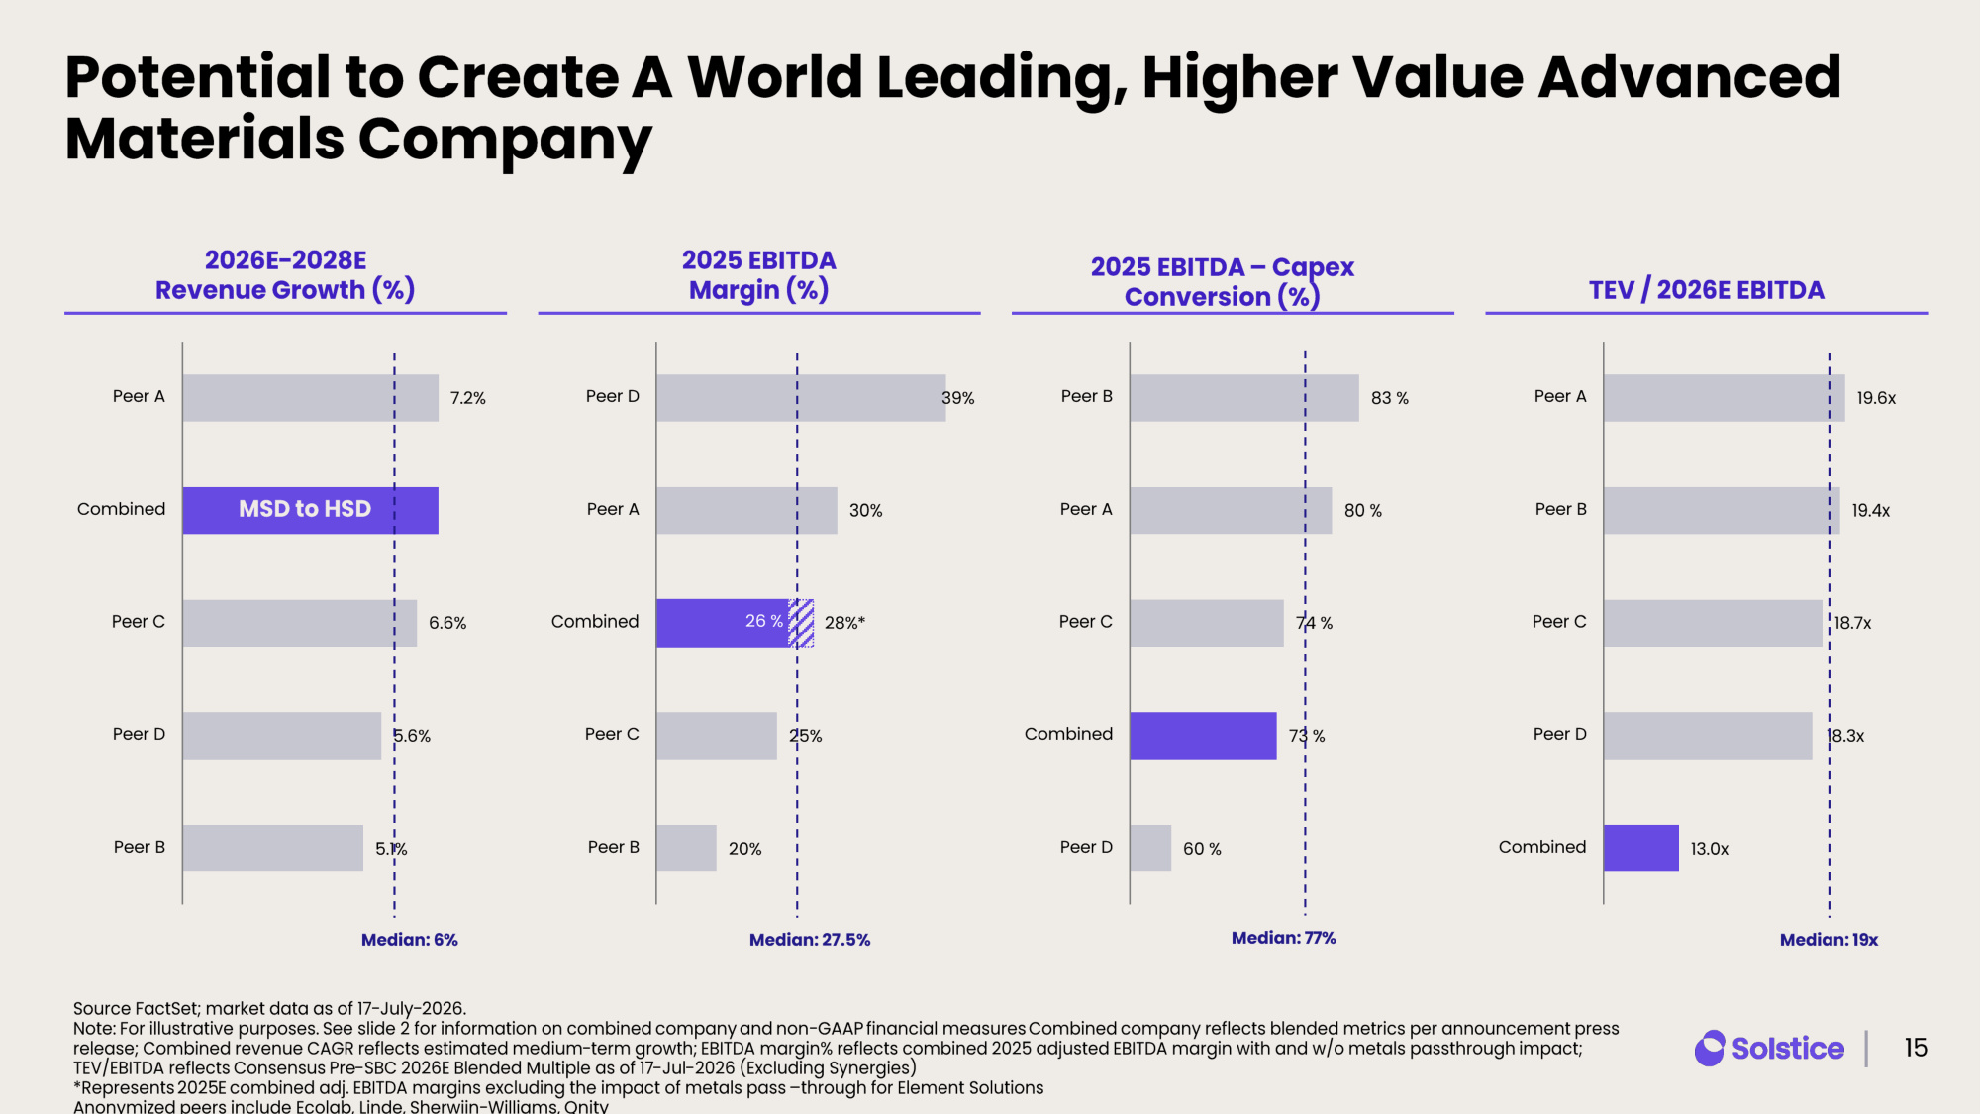
Source FactSet; market data as of 17 - July - 2026. Note: For illustrative purposes. See slide 2 for information on combined company and non - GAAP financial measures Combined company reflects blended metrics per announcement press release; Combined revenue CAGR reflects estimated medium - term growth; EBITDA margin% reflects combined 2025 adjusted EBITDA margin with and w/o metals passthrough impact; TEV/EBITDA reflects Consensus Pre - SBC 2026E Blended Multiple as of 17 - Jul - 2026 (Excluding Synergies) *Represents 2025 E combined adj. EBITDA margins excluding the impact of metals pass – through for Element Solutions Anonymized peers include Ecolab, Linde, Sherwiin - Williams, Qnity Potential to Create A World Leading, Higher Value Advanced Materials Company 15 TEV / 2026E EBITDA 19.6x 19.4x 18.7x 18.3x 13.0x Peer A Peer B Peer C Peer D Combined Median: 19 x 7.2% 6.6% 5.6% 5.1% Peer A Combined Peer C Peer D Peer B 2026E - 2028E Revenue Growth (%) Median: 6 % 2025 EBITDA Margin (%) 26 % 39% 30% 28% * 25% 20% Peer D Peer A Combined Peer C Peer B Median: 27.5% 2025 EBITDA – Capex Conversion (%) 83 % 80 % 74 % 73 % 60 % Peer B Peer A Peer C Combined Peer D Median: 7 7% MSD to HSD

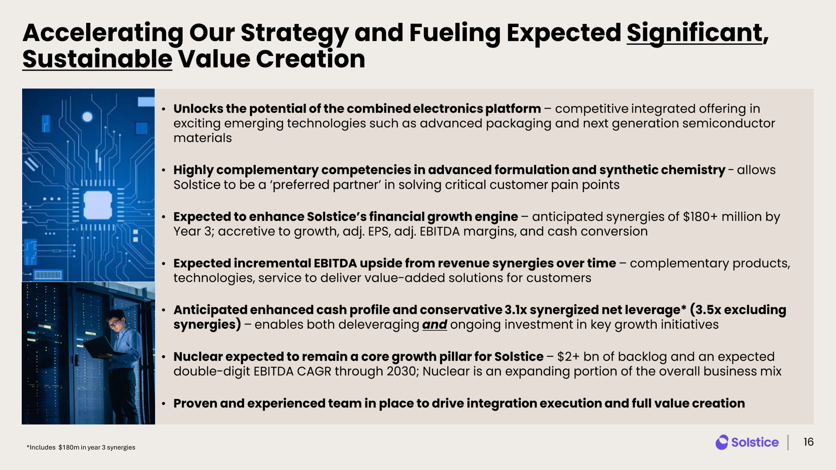
Accelerating Our Strategy and Fueling Expected Significant , Sustainable Value Creation • Unlocks the potential of the combined electronics platform – competitive integrated offering in exciting emerging technologies such as advanced packaging and next generation semiconductor materials • Highly complementary competencies in advanced formulation and synthetic chemistry - allows Solstice to be a 'preferred partner' in solving critical customer pain points • Expected to enhance Solstice's financial growth engine – anticipated synergies of $180+ million by Year 3; accretive to growth, adj. EPS, adj. EBITDA margins, and cash conversion • Expected incremental EBITDA upside from revenue synergies over time – complementary products, technologies, service to deliver value - added solutions for customers • Anticipated enhanced cash profile and conservative 3.1x synergized net leverage* (3.5x excluding synergies) – enables both deleveraging and ongoing investment in key growth initiatives • Nuclear expected to remain a core growth pillar for Solstice – $2+ bn of backlog and an expected double - digit EBITDA CAGR through 2030; Nuclear is an expanding portion of the overall business mix • Proven and experienced team in place to drive integration execution and full value creation 16 *Includes $180m in year 3 synergies


Appendix © 2026 Solstice Advanced Materials Inc.

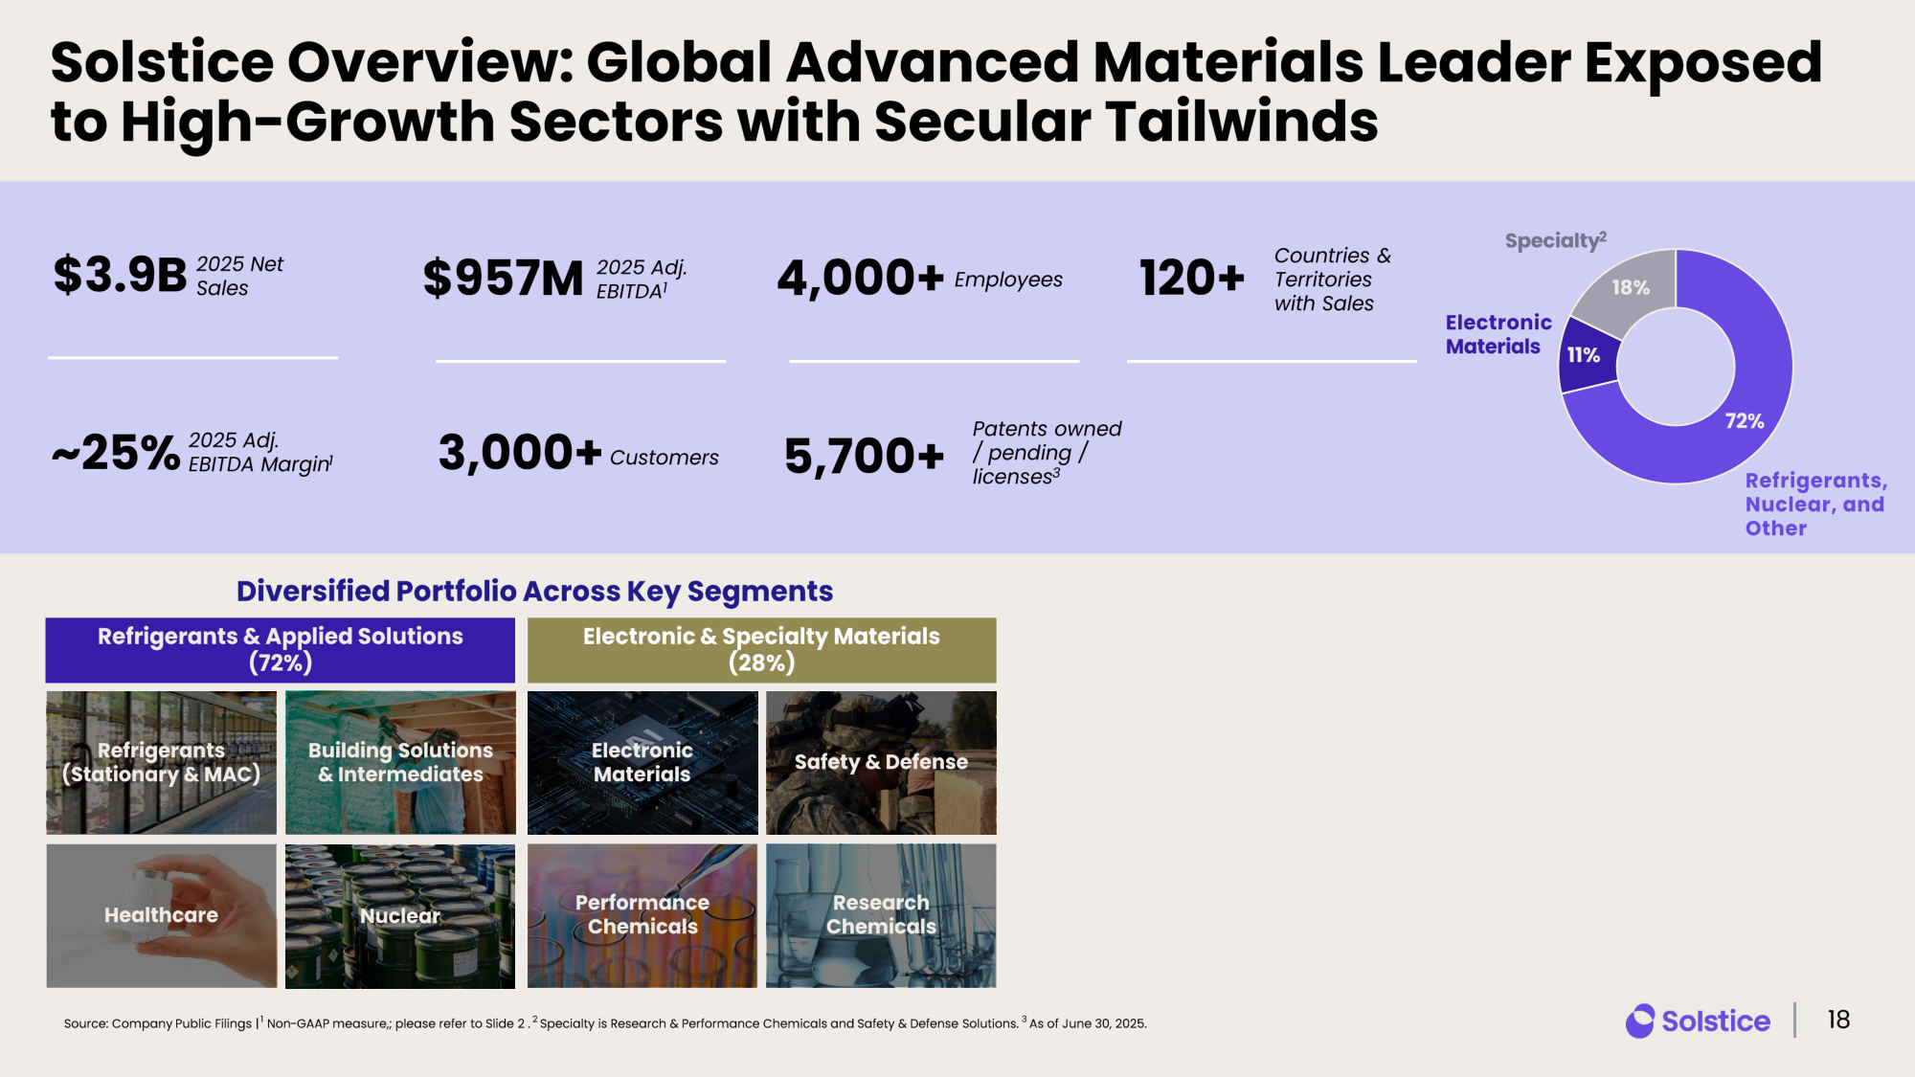
Solstice Overview: Global Advanced Materials Leader Exposed to High - Growth Sectors with Secular Tailwinds Diversified Portfolio Across Key Segments 2025 Net Sales $3.9B 2025 Adj. EBITDA Margin 1 ~25% 2025 Adj. EBITDA 1 $957M Employees 4,000+ Customers 3,000+ Countries & Territories with Sales 120+ Patents owned / pending / licenses 3 5,700+ Refrigerants & Applied Solutions (72%) Electronic & Specialty Materials (28%) Healthcare Refrigerants (Stationary & MAC) Electronic Materials Source: Company Public Filings | 1 Non - GAAP measure,; please refer to Slide 2 . 2 Specialty is Research & Performance Chemicals and Safety & Defense Solutions. 3 As of June 30, 2025. Nuclear Safety & Defense Research Chemicals Performance Chemicals Building Solutions & Intermediates 18 72% 11% 18% Specialty 2 Electronic Materials Refrigerants, Nuclear, and Other

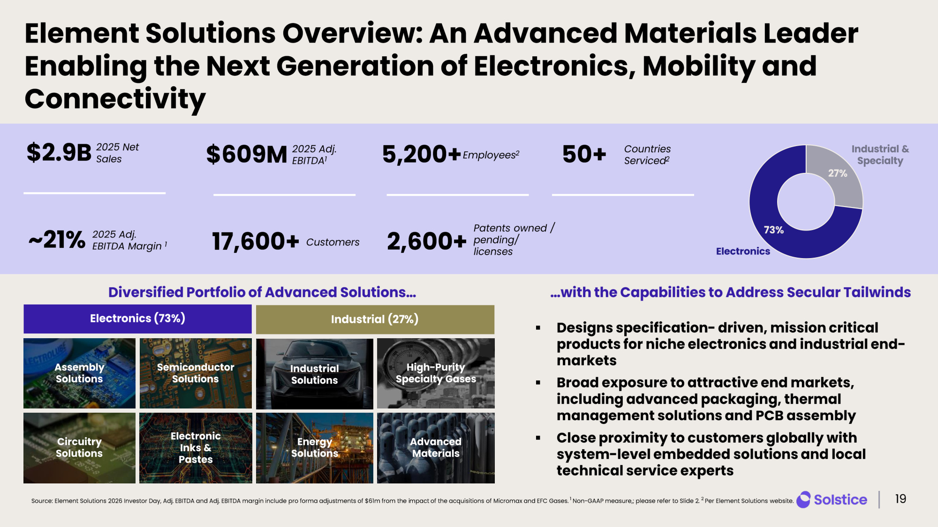
Element Solutions Overview: An Advanced Materials Leader Enabling the Next Generation of Electronics, Mobility and Connectivity Diversified Portfolio of Advanced Solutions... 2025 Net Sales $2.9B 2025 Adj. EBITDA Margin 1 ~21% 2025 Adj. EBITDA 1 $609M Employees 2 5,200+ Customers 17,600+ Countries Serviced 2 50+ Patents owned / pending/ licenses 2,600 + ...with the Capabilities to Address Secular Tailwinds Circuitry Solutions Assembly Solutions Electronic Inks & Pastes Semiconductor Solutions Industrial Solutions Energy Solutions High - Purity Specialty Gases Advanced Materials Electronics (73%) Industrial ( 27%) ▪ Designs specification - driven, mission critical products for niche electronics and industrial end - markets ▪ Broad exposure to attractive end markets, including advanced packaging, thermal management solutions and PCB assembly ▪ Close proximity to customers globally with system - level embedded solutions and local technical service experts 19 27% 73% Electronics Industrial & Specialty Source: Element Solutions 2026 Investor Day, Adj. EBITDA and Adj. EBITDA margin include pro forma adjustments of $61m from th e i mpact of the acquisitions of Micromax and EFC Gases. 1 Non - GAAP measure,; please refer to Slide 2 . 2 Per Element Solutions website.

