Filed by Solstice Advanced Materials Inc.
Pursuant to Rule 425 under the Securities Act of 1933, as amended
and deemed filed pursuant to Rule 14a-12
under the Securities Exchange Act of 1934, as amended
Subject Company: Element Solutions Inc
(Commission File No. 001-36272)

The following communication is being filed in connection with the proposed transaction between Solstice Advanced Materials Inc. (“Solstice”) and Element Solutions Inc (“Element Solutions”).

The following are excerpts relating to the proposed transaction from a Solstice employee town hall held on August 6, 2026.

David Sewell:

2027, we believe, is going to be another great year for the company. We'll also, welcome our acquisitions, so we'll be a really strong, growing, scalable company that we believe will be what we're calling just an advanced materials powerhouse in the industry. I mean, when you look at our portfolio, what we're going to be able to do for customers, and the segments we operate in.

With the margin profile we have, with the growth profile we have, with the innovation, and the people, we think this is going to be the leading company in advanced materials, and we just can't wait to demonstrate that, in the future.

So let's talk about Element Solutions. Let me just give you a little bit of an update on where we're at in the acquisitions, and then I have a slide here that talks a little bit about timing, and then obviously we'll have Q&A, and I want to answer any and every question you have.

On Element as we move forward. The number one piece of Element is, and the most attractive reason why we did it, is it really positions us as a leader in, advanced computing.

So when you think about our electronics business, and wear that out, we have this amazing refrigerants business, across the board, and then if you look at our electronics business, it's growing like crazy. We're doubling the site of our, of our Spokane facility as we speak. We're accelerating that. Our order backlog is unbelievable.

But when you think about the company, and where we want to take the company. I want you not to think about electronics and refrigerants. I want us to think about, strategically, we are going to be an AI Critical infrastructure company.

So what does that mean? Because with the progression of AI, and AI is here to stay, and we can debate the data center growth separately, but AI will be the next baseline for how companies operate well into the future.

And with that, with all the NVIDIAs and TSMCs and Samsungs and Intels and everybody that's out there. It's not just their growth, there's an infrastructure that needs to support their growth. And these are now trillion-dollar valuation companies. That's how fast these companies are growing.

And so, with that, think about what goes in. So you've got the semiconductor side which now we have an end-to-end portfolio that we think is going to be one of the leading portfolios in the world. We'll have integrated solutions that nobody has, we'll have, we'll be on the front end, we'll be on, in advanced packaging, which is growing double digits. We're gonna have the best thermal management solutions, so we are just gonna have a complete portfolio on that piece of it.

And then you think about the cooling side of it. And whether it's cooling the data center, thermal management, and other aspects of everything that goes on. Next-generation innovation cooling on the chip, whether it's two-phase directed chip, immersion cooling. We're gonna be able to do things that nobody else can do, from that standpoint.

And then you gotta power the, right? You gotta power those data centers, which is a huge concern, and that's where you're seeing the advent of SMR technology, and that's where our nuclear business comes in.

It's just an amazing opportunity for us, because if you want to invest in critical infrastructure on where all these investments are going over the next decade plus. Which is going to be growing faster than we think almost any segment in the world.

We're gonna have a complete portfolio. And then you think about our other businesses is, you know, their platforms. So if you think about our HFOs, yes, they go into cooling, yes, they go into…nuclear, but, you know, hydrogen fluoride, we have it in other things. It goes into BSI, it goes into medical. So that's a growth avenue on common platforms. We, you know, we use the common R&D teams, you know, we're able to leverage our manufacturing footprint. So, now we have a core business, and then we have organic growth opportunities on top of it. But we are going to be a critical infrastructure company, and now Element Solutions allows us to be a leader

In the electronics side, and it'll bring everything together. So, we couldn't be more excited about it, and we just think the future for this company is as bright as it's ever been, and, we're excited about what's to come next.

So, what does a new company look like? So, we'll be, from 2025 revenue standpoint, $6.8 billion, so obviously, with the growth, we'll be over $7 billion as we head into 2027.

We're gonna have leading margins at 26%. You can see some of the growth rates and what's going on, and why we're so excited about being part of this. So you think about advanced computing, next-generation cooling, power demand.

And then platforms where we can grow organically off these innovations. This is an end-to-end market that we couldn't be more excited about, and has positioned Solstice strategically as a leader in this critical infrastructure on this new growth platform as we move forward.

But what does it mean for employees? And this is where I hope employees get really excited.

So, as we continue to grow, when you grow double digits, and you are now expanding, globally, you have depths of market, this provides unbelievable growth opportunities for employees. We are really excited about the career opportunities you now have.

We are a stronger, more global company, we have more scale, we have more money for investment in our organic growth, more R&D opportunities. It helps us with our capital spending for our manufacturing sites. So, we're really excited what this brings for our employees, whether it's at the plant, whether it's on the commercial side, whether on the functional side.

We are just going to be a much more scalable company that's just going to provide more opportunities.

And, you know, wherever we can, develop our people, promote internally within, that's exactly what we're gonna do. So I hope you're as excited about the opportunities for you as we are for our customers and our shareholders. And so…

There's just gonna be…A different aspect, and we'll do a lot of change management, because we'll want to combine as we integrate the two companies, how do we take the best of both? So there'll be some great learnings we get from Element, and there'll be some great best practices on the Solstice side, and we'll blend those together, and we'll be able to really have a truly customer focus, execution-oriented company that really outpaces the market.

So, that's kind of where we're at with Element. The integration team is doing an amazing job preparing us. We've just kicked off with the Element leadership team, and we'll have work streams, across functions, across regions. Many of you are going to be heavily involved. Along with the Element team in really helping us drive what's our operating model gonna be? Where are the opportunities for us, to continue to grow faster and take advantage of making… how do we make 1 plus 1 equal 3 with our two companies coming together? So that process is starting. And you will be getting a lot more information on that, and we have a website hub on the integration, and that will be continued to update, so you guys have information on what's happening.

Employee:

Hi. Another question on the acquisition of Element. Since it's been a month since we announced, what has been the initial feedback from our customers? Has it… our electronics customers, has it been mostly positive? Has there been any doubts?

David Sewell:

Really great question. I'm actually going to, I asked Simon to, and we used some quotes from customers. In some of our investor materials. Simon, I'm gonna put you on the spot. Because we asked Simon to get directly with customers, get their feedback, and I'll let you hear it straight from the leader of our electronics business.

Simon Mawson:

Thank you. So yesterday, or two days ago, I was out at Spokane. We did the, final beam installation on Spokane, so we all signed the beam and they hoisted it up, and you'll see photos of this coming out shortly. But we had Gary Chen, who is the head of procurement for TSMC, sort of our key contact there for the Beam signing ceremony. And so we actually got quite a bit of time with Gary, both at dinner and then during the day for the Beam signing ceremony. And, you know, across the board, you know, the feedback from Gary is extremely positive.

So they have a situation today where, as the advanced packaging business, for example, starts to grow, they're struggling with suppliers and their current supplier situation, because a lot of the suppliers into that space are not as well equipped to serve the electronics industry as, say, the front-end suppliers like ourselves.

So they want to see us accelerate what we're doing at advanced packaging, and pull in what we do on the front end into the back end, and support them in a much more meaningful way as they grow out their advanced packaging business.

In the same time, they also have, they have to buy substrates, they have to buy PCB boards as they manufacture for their customers, because their customers are asking them to do more and more.

So, that's another area where they have a pain point and they need help, and with Element, we're gonna have a leading position in PCB board manufacturing and capability. So when you think across the entire value chain, so from front end. packaging, PCB board, final assembly. There's an incredible opportunity with someone like TSMC, for example, to become a much more significant strategic partner for them, to help them with all that, because they're struggling with it, because there's so few suppliers, or no suppliers, that can really help them across it. heard the same feedback from Samsung, so the Samsung conversation, they want to have a technology review meeting, like, next week, which we can't do until we do the close. And then similar feedback from Intel as well, that, you know, lots of opportunity. So, I think there's going to be amazing opportunity here with our customers, to do much more, much faster, and to become much more of an innovation partner with them, end-to-end across the whole value chain. So the initial feedback is extremely positive. Perfect.

Jason Clifford:

Thanks, Brian. So, before we close, you know, just want to highlight, you talked about it in your comments, there's a lot of… lot of energy around Element, and I know there's a lot of interest, in… so, similar to what we did with the spin, David mentioned that, you know, we've created… on the intranet site, we've put together, you know, a placeholder, you know, the acquisition hub, per se.

Our goal is always to try to be as transparent as we possibly can, and we're going to continue to put information out there as much as we possibly can, and as we have information, and that's our commitment, to the employees, and understand there's a lot of questions, and right now, there's just not a lot of answers.

So, as we go through, we will continue to put information out there. I'd ask you to go and continue to look at that site, and it gives you an opportunity to kind of learn more about it as we go through over the next several months.

With that, Dave, a closing…

David Sewell:

Yeah, so, first off, thank you again for another great quarter. Each and every one of you, absolutely played a critical role in that. As Jeff, reminded us all, there's only two jobs here. We either sell advanced materials or we help sell it, and you all have done all of that, and that is so important for us as we go into this spin.

Look, I know there's a lot of, you know, what-ifs on Element, and I just want to just continue to put your mind at ease that this is going to be an unbelievable opportunity for this company, for us to be able to build this scale.

And get in at the early innings of AI and this critical infrastructure around it. And to demonstrate the innovation that Simon even alluded to, where customers just need more and more. I think TSMC has announced, probably, Simon, $300 billion of investment in, in, in Arizona for chip fabrication. That's a good place to be. Where customers are spending $300 billion, and that's not even all the other aspects that's going on.

And then the innovations that the R&D team's working on, with the commercial excellence work that's going on, and gaining share. I am so excited about the future of this company, and I can't wait for all of us to share in the successes that we have in the future that you all created. So, with that, we'll let you go, and can't wait to talk to you all next quarter. Thank you very much.

The following are excerpts from a Solstice employee town hall presentation on August 6, 2026.

 | 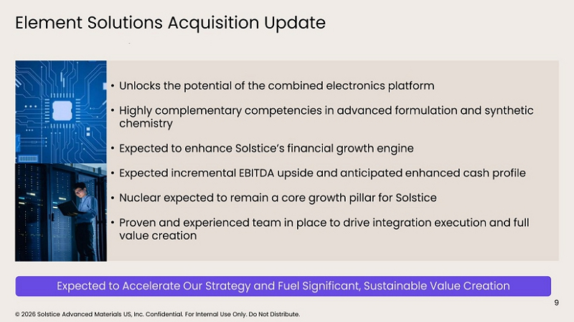 | © 2026 Solstice Advanced Materials US, Inc. Confidential. For Internal Use Only. Do Not Distribute. Element Solutions Acquisition Update • Unlocks the potential of the combined electronics platform • Highly complementary competencies in advanced formulation and synthetic chemistry • Expected to enhance Solstice’s financial growth engine • Expected incremental EBITDA upside and anticipated enhanced cash profile • Nuclear expected to remain a core growth pillar for Solstice • Proven and experienced team in place to drive integration execution and full value creation 9 Expected to Accelerate Our Strategy and Fuel Significant, Sustainable Value Creation

 | 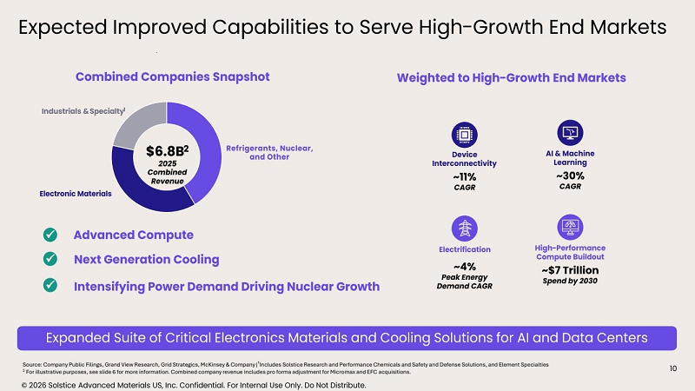 | Expected Improved Capabilities to Serve High - Growth End Markets 10 Source: Company Public Filings, Grand View Research, Grid Strategics, McKinsey & Company |¹Includes Solstice Research and Performance Chemicals and Safety and Defense Solutions, and Element Specialties 2 For illustrative purposes, see slide 6 for more information. Combined company revenue includes pro forma adjustment for Micromax and EFC acquisitions. $6.8B 2 2025 Combined Revenue Electronic Materials Industrials & Specialty 1 Refrigerants, Nuclear, and Other Next Generation Cooling Intensifying Power Demand Driving Nuclear Growth ✓ Advanced Compute ✓ ✓ Expanded Suite of Critical Electronics Materials and Cooling Solutions for AI and Data Centers Device Interconnectivity AI & Machine Learning Electrification High - Performance Compute Buildout ~11% CAGR ~30% CAGR ~$7 Trillion Spend by 2030 ~4% Peak Energy Demand CAGR Weighted to High - Growth End Markets © 2026 Solstice Advanced Materials US, Inc. Confidential. For Internal Use Only. Do Not Distribute. Combined Companies Snapshot

 | 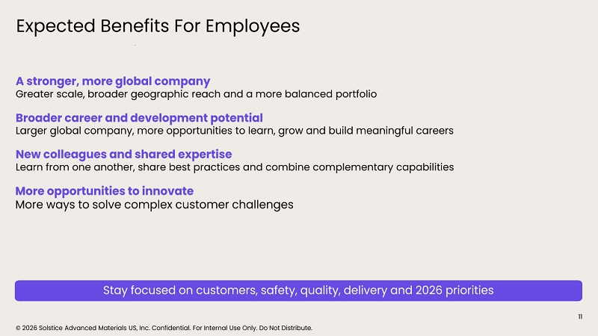 | © 2026 Solstice Advanced Materials US, Inc. Confidential. For Internal Use Only. Do Not Distribute. Expected Benefits For Employees Expected Benefits For Employees A stronger, more global company Greater scale, broader geographic reach and a more balanced portfolio Broader career and development potential Larger global company, more opportunities to learn, grow and build meaningful careers New colleagues and shared expertise Learn from one another, share best practices and combine complementary capabilities More opportunities to innovate More ways to solve complex customer challenges 11 Stay focused on customers, safety, quality, delivery and 2026 priorities

 | 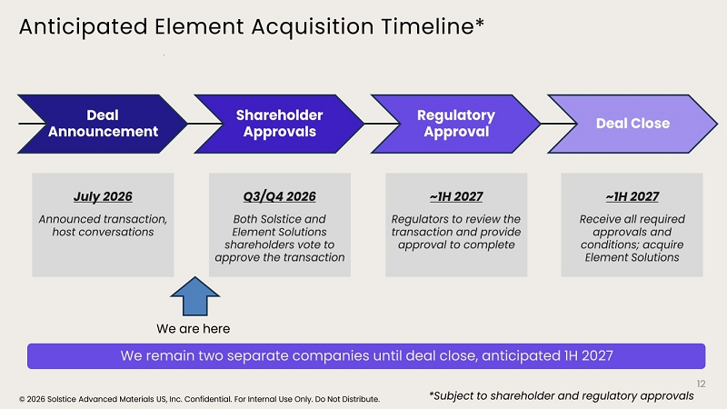 | © 2026 Solstice Advanced Materials US, Inc. Confidential. For Internal Use Only. Do Not Distribute. Anticipated Element Acquisition Timeline* Anticipated Element Acquisition Timeline* 12 July 2026 Announced transaction, host conversations Q3/Q4 2026 Both Solstice and Element Solutions shareholders vote to approve the transaction ~1H 2027 Regulators to review the transaction and provide approval to complete ~1H 2027 Receive all required approvals and conditions; acquire Element Solutions Deal Announcement Shareholder Approvals Regulatory Approval Deal Close We remain two separate companies until deal close, anticipated 1H 2027 *Subject to shareholder and regulatory approvals We are here

Cautionary Statement Regarding Forward-Looking Statements

This communication contains certain forward-looking statements within the meaning of the federal securities laws made pursuant to the safe harbor provisions of the Private Securities Litigation Reform Act of 1995 with respect to the proposed transaction between Solstice and Element Solutions, that involve substantial risks and uncertainties. These statements can be identified by the fact that they do not relate strictly to historical or current facts, but rather are based on current expectations, estimates, assumptions and projections regarding, among other things, the anticipated benefits and timing of the proposed transaction, synergies, expected future financial position, total addressable market, position in specialty chemicals and advanced materials verticals and the industry, business and financial results of each company and the combined company, including the combined company’s expected Adjusted EBITDA and Adjusted EBITDA margin, expected synergies, net debt and net leverage, anticipated de-leveraging, expected accretion to Adjusted EPS and expected growth, margins and free cash flow. Forward-looking statements often include words such as “anticipates,” “estimates,” “expects,” “positioned,” “projects,” “forecasts,” “intends,” “plans,” “continues,” “could,” “believes,” “may,” “will,” “would,” “should,” “goals,” “pro forma” and words and terms of similar substance in connection with discussions of the proposed transaction and the future operating or financial performance of the combined company. As with any projection or forecast, forward-looking statements are inherently susceptible to uncertainty and changes in circumstances. Solstice’s, Element Solutions’ or the combined company’s actual results may vary materially from those expressed or implied in the forward-looking statements. Accordingly, undue reliance should not be placed on any forward-looking statement made by Solstice or on its behalf. Although Solstice and Element Solutions believe that the forward-looking statements contained in this communication are based on reasonable assumptions, you should be aware that a variety of factors, many of which are difficult to predict and outside of Solstice’s or Element Solutions’ control, could affect Solstice’s, Element Solutions’ or the combined company’s actual financial results or results of operations and could cause actual results to differ materially from those in such forward-looking statements, including, but not limited to: the completion of the proposed transaction on the anticipated terms and timing, including obtaining stockholder, regulatory and other approvals, anticipated tax treatment, unforeseen liabilities, future capital expenditures, revenues, expenses, earnings, synergies, economic performance, indebtedness, financial condition, future prospects, business and management strategies, expansion and growth of Solstice’s and Element Solutions’ businesses and other conditions to the completion of the proposed transaction; failure to realize the anticipated benefits of the proposed transaction, or that such benefits may take longer to realize or be more costly to achieve than expected, including as a result of delay in completing the proposed transaction, Solstice’s ability to integrate Element Solutions’ operations and product lines or due to unexpected costs, liabilities or delays; the ability of the parties to obtain or consummate financing related to the proposed transaction upon acceptable terms or at all; the dilution caused by Solstice’s issuance of additional shares of its common stock in connection with the consummation of the proposed transaction; the risk of a downgrade of the credit rating of Solstice’s indebtedness; a material adverse change in the financial condition of Solstice, Element Solutions or the combined company; potential litigation relating to the proposed transaction that could be instituted against Solstice, Element Solutions or their respective directors; Solstice’s and Element Solutions’ ability to implement their business strategies; the risk that disruptions from the proposed transaction will harm Solstice’s or Element Solutions’ respective businesses, including current plans and operations; the ability of Solstice or Element Solutions to retain and hire key personnel; potential adverse reactions or changes to business relationships resulting from the announcement or completion of the proposed transaction; uncertainty as to the long-term value of Solstice’s common stock; risks associated with third party contracts containing consent and/or other provisions triggered by the proposed transaction; legislative, regulatory, political and economic developments affecting Solstice’s, Element Solutions’ or the combined company’s respective businesses; the evolving legal, regulatory and tax regimes under which Solstice and Element Solutions operate; potential business uncertainty, including changes to existing business relationships, during the pendency of the proposed transaction that could affect Solstice’s and/or Element Solutions’ financial performance; restrictions during the pendency of the proposed transaction that may impact Solstice’s or Element Solutions’ ability to pursue certain business opportunities or strategic transactions; an overall decline in the health of the economy and the industries in which Solstice and Element Solutions operate, including as a result of inflation, tariffs and other trade barriers and restrictions, market volatility, geopolitical instability and social unrest, the possibility of an economic downturn or recession or other macroeconomic factors; unpredictability and severity of catastrophic events, including, but not limited to, acts of terrorism or outbreak of war or hostilities, as well as Solstice’s and Element Solutions’ response to any of the aforementioned factors; failure to receive the approval of the stockholders of Solstice and/or Element Solutions; and the occurrence of any event, change or other circumstance that could give rise to the termination of the merger agreement. The foregoing list of factors is not exhaustive. You should carefully consider the foregoing factors and the other risks and uncertainties that affect the businesses of Solstice and Element Solutions described in the “Risk Factors” section of their respective Annual Reports on Form 10-K for the year ended December 31, 2025, Quarterly Reports on Form 10-Q and other documents filed by either of them from time to time with the SEC. These filings identify and address other important risks and uncertainties that could cause actual events and results to differ materially from those implied by forward-looking statements in this communication. Forward-looking statements speak only as of the date they are made. Readers are cautioned not to put undue reliance on forward-looking statements, and Solstice and Element Solutions assume no obligation and do not intend to update or revise these forward-looking statements, whether as a result of new information, future events or otherwise, except as otherwise required by securities or other applicable law. Neither Solstice nor Element Solutions gives any assurance that either Solstice or Element Solutions will achieve its expectations.

Important Information and Where to Find It

In connection with the proposed transaction, Solstice intends to file with the SEC a registration statement on Form S-4 (the “Registration Statement”), which will include a prospectus with respect to the shares of Solstice’s common stock to be issued in the proposed transaction and a joint proxy statement for Solstice’s and Element Solutions’ respective stockholders (the “Joint Proxy Statement/Prospectus”). The definitive Joint Proxy Statement/Prospectus (if and when available) will be mailed to stockholders of Solstice and Element Solutions after it is declared effective. Each of Solstice and Element Solutions may also file with or furnish to the SEC other relevant documents regarding the proposed transaction. This communication is not a substitute for the Registration Statement, the Joint Proxy Statement/Prospectus or any other document that Solstice or Element Solutions may mail to their respective stockholders in connection with the proposed transaction.

INVESTORS AND SECURITY HOLDERS OF SOLSTICE AND ELEMENT SOLUTIONS ARE URGED TO READ THE REGISTRATION STATEMENT AND THE JOINT PROXY STATEMENT/PROSPECTUS INCLUDED WITHIN THE REGISTRATION STATEMENT CAREFULLY AND IN THEIR ENTIRETY WHEN THEY BECOME AVAILABLE, AS WELL AS ANY OTHER RELEVANT DOCUMENTS FILED WITH THE SEC IN CONNECTION WITH THE PROPOSED TRANSACTION OR INCORPORATED BY REFERENCE INTO THE REGISTRATION STATEMENT AND THE JOINT PROXY STATEMENT/PROSPECTUS (INCLUDING ANY AMENDMENTS OR SUPPLEMENTS THERETO), BECAUSE THEY WILL CONTAIN IMPORTANT INFORMATION REGARDING SOLSTICE, ELEMENT SOLUTIONS, THE PROPOSED TRANSACTION AND RELATED MATTERS.

Investors and security holders may obtain free copies of the Joint Proxy Statement/Prospectus and other documents filed with the SEC by Solstice or Element Solutions through the website maintained by the SEC at http://www.sec.gov or from Solstice at its website, https://www.solstice.com, or from Element Solutions at its website, https://www.elementsolutionsinc.com (information included on or accessible through the SEC website or either of Solstice’s or Element Solutions’ website is not incorporated by reference into this communication).

Participants in Solicitation

Solstice and Element Solutions and their respective directors and executive officers may be deemed to be participants in the solicitation of proxies from the stockholders of Solstice and Element Solutions in connection with the proposed transaction.

Information about the interests of the directors and executive officers of Solstice and Element Solutions and other persons who may be deemed to be participants in the solicitation of stockholders of Solstice and Element Solutions in connection with the proposed transaction and a description of their direct and indirect interests, by security holdings or otherwise, will be included in the Joint Proxy Statement/Prospectus, which will be filed with the SEC.

Information about Solstice’s directors and executive officers and their ownership of Solstice’s common stock is set forth in Solstice’s proxy statement for its 2026 Annual Meeting of Stockholders on Schedule 14A filed with the SEC on April 2, 2026 under the headings “Director Compensation,” “Compensation Discussion and Analysis,” “Executive Compensation Tables” and “Stock Ownership Information.” To the extent that holdings of Solstice’s securities have changed since the amounts printed in Solstice’s proxy statement, such changes have been or will be reflected on Initial Statements of Beneficial Ownership of Securities on Form 3 and Statements of Changes in Beneficial Ownership on Form 4 filed with the SEC.

Information about Element Solutions’ directors and executive officers and their ownership of Element Solutions’ common stock is set forth in Element Solutions’ proxy statement for its 2026 Annual Meeting of Stockholders on Schedule 14A filed with the SEC on March 23, 2026 under the headings “Director Compensation,” “Executive Compensation” and “Security Ownership.” To the extent that holdings of Element Solutions’ securities have changed since the amounts printed in Element Solutions’ proxy statement, such changes have been or will be reflected on Initial Statements of Beneficial Ownership of Securities on Form 3 and Statements of Changes in Beneficial Ownership on Form 4 filed with the SEC.

The information regarding the direct and indirect interests of those persons and other persons who may be deemed participants in the proposed transaction may be obtained by reading the Joint Proxy Statement/Prospectus regarding the proposed transaction when it becomes available. Free copies of these documents may be obtained as described above.

No Offer or Solicitation

This communication is not intended to and shall not constitute an offer to sell or the solicitation of an offer to sell or the solicitation of an offer to buy any securities, or a solicitation of any vote or approval, nor shall there be any sale of securities in any jurisdiction in which such offer, solicitation or sale would be unlawful prior to registration or qualification under the securities laws of any such jurisdiction. No offer of securities shall be made except by means of a prospectus meeting the requirements of Section 10 of the Securities Act of 1933, as amended (the “Securities Act”), and/or offered pursuant to an exemption from the registration requirements of the Securities Act, and otherwise in accordance with applicable law.

Important Note about Combined and Non-GAAP Financial Information

The financial information for the combined businesses of Solstice and Element Solutions is based on management's estimates, assumptions and projections and has not been prepared in conformance with the applicable requirements of Regulation S-X relating to pro forma financial information, and the required pro forma adjustments have not been applied and are not reflected therein. This information is provided for illustrative purposes only and should not be considered in isolation from, or as a substitute for, the historical financial statements of Solstice and Element Solutions. These measures are provided for illustrative purposes and are based on an arithmetic sum of the relevant historical financial measures of Solstice and Element Solutions. Combined Adjusted EBITDA is the arithmetic sum of Solstice’s Adjusted Standalone EBITDA and Element Solutions’ Pro Forma Adjusted EBITDA, inclusive of expected synergies. Combined Adjusted EBITDA Margin is inclusive of expected synergies. These measures do not reflect what the combined company's financial condition or results of operations would have been had the proposed transaction occurred on or prior to the dates indicated. Such illustrative information may differ materially from pro forma information included in SEC filings. Various factors could cause actual future results to differ materially from those currently estimated by management, including, but not limited to, the risks described above and in each of Solstice’s and Element Solutions’ respective filings with the SEC.

This communication also includes certain financial measures not calculated in accordance with U.S. generally accepted accounting principles ("GAAP"), such as adjusted standalone EBITDA, pro forma adjusted EBITDA, combined adjusted EBITDA, combined adjusted EBITDA margin, combined sales, synergies, integration benefits, free cash flow, net debt and net leverage. Non-GAAP financial measures have limitations as an analytical tool and are not meant to be considered in isolation from, or as a substitute for, the comparable GAAP measures. There are limitations to non-GAAP financial measures because they are not prepared in accordance with GAAP and may not be comparable to similarly titled measures of other companies due to potential differences in methods of calculation and items being excluded. Solstice and Element Solutions caution you not to place undue reliance on these non-GAAP financial measures.

For a definition of Solstice’s adjusted standalone EBITDA and Element Solutions’ adjusted EBITDA and a reconciliation of adjusted standalone EBITDA and adjusted EBITDA to the most comparable GAAP financial measure for 2025, please see Solstice’s Current Report on Form 8-K furnished with the SEC on February 11, 2026 and Element Solutions’ Current Report on Form 8-K furnished with the SEC on February 17, 2026 and Element Solutions’ 2026 Investor Day presentation at its website at https://www.elementsolutions.com (information included on or accessible through Element Solutions’ website is not incorporated by reference into this communication). Element Solutions’ pro forma Adjusted EBITDA for fiscal year 2025 is from Element Solutions’ 2026 Investor Day presentation and is Element Solutions’ Adjusted EBITDA inclusive of a pro forma adjustment of $61 million from the impact of the acquisitions of Micromax and EFC Gases. Combined Adjusted EBITDA and Combined Adjusted EBITDA margin includes expected synergies.

